

Budgetary Management Subsystem

Software Requirement Specification Document

**Project Code： BMS**

**Document Code： SRS– v1.1**

**Hanoi、17th October 2015**

Change history

* A –Add new、M - Modified、D – Delete

|  |  |  |  |  |
| --- | --- | --- | --- | --- |
| Date | Change Item | A* M、D | Change content | Version |
| 2015/10/17 | Introduction | A | Add new | 1.0 |
| 2015/10/17 | Functional Specification | A | Add new | 1.0 |
| 2015/10/25 | Introduction | M | Update | 1.1 |
| 2015/10/25 | Overall description | A | Add new | 1.1 |
| 2015/10/25 | Functional Specification | M | Update | 1.1 |
| 2015/10/25 | Non-functional | A | Add new | 1.1 |
| 2015/10/28 | Functional Specification | M | Update | 1.1 |
|  |  |  |  |  |
|  |  |  |  |  |
|  |  |  |  |  |
|  |  |  |  |  |
|  |  |  |  |  |
|  |  |  |  |  |
|  |  |  |  |  |
|  |  |  |  |  |
|  |  |  |  |  |
|  |  |  |  |  |
|  |  |  |  |  |
|  |  |  |  |  |
|  |  |  |  |  |
|  |  |  |  |  |
|  |  |  |  |  |

Signature page

**Create：** Phan Huy Hung Date: 2015/10/17

Developer

**Review：** Nguyen Ba Tu Date: 2015/10/20

Developer

**Approve：** Nguyen Van Vung Date: 2015/10/21

Project Manager

Table of contents

1. INTRODUCTION 5

1.1 Purpose 5

1.2 Scope 5

1.3 Definition, Acronyms and Abbreviation 6

1.4 Overview 7

2. OVERALL DESCRIPTION 8

2.1 System Overview 8

2.2 Use Case Diagram 9

2.3 Product Functions 9

2.4 User Characteristic 13

2.5 Assumption 13

3. FUNCTIONAL SPECIFICATION 13

3.1 Budget Estimation 13

3.2 Additional Budget Estimation 27

3.3 Allocation 49

3.4 Budget Settlement 59

4. NON-FUNCTIONAL SPECIFICATION 77

4.1 Reliability 77

4.2 Availability 77

4.3 Performance 77

4.4 Maintainability 78

4.5 Usability 78

4.6 Security 78

4.7 Hardware/Software Requirements 78

# INTRODUCTION

This section gives a scope description and overview of everything included in this SRS document. Also, the purpose for this document is described and a list of abbreviations and definitions is provided.

## Purpose

This is the Software Requirements Specification for the “Budgetary Management Subsystem” (BMS). This document will provide the describing of general requirement and non-functional requirements of our BMS system. These requirements will assure that the system will correctly and reliably perform its intended functionality. This specification will provide general, as well as specific requirements to be used in the design, testing and validation of the system. It is intended for both stakeholders and the project team of the system.

## Scope

### Introduction of Existing System

Department of Finance has financial management system (FMS) that was firstly developed in 2012 and built on Web local application to manage finance for Viet Nam Ministry of National Defense. FMS is being used in internal of financial department. The system includes 6 subsystems:

* Accounting management
* Invested capital management
* Corporate finance management
* Document management
* Price management
* Public assets management

The BMS subsystem will be development to integration in FMS.

### Objective of BMS

The Budgetary Management System is a subsystem of FMS that built on Web local application in which employee can manage budgetary data by electronic data, exchanging data with other agencies and provide reports. This subsystem is focused on developing the budgetary management system includes:

* Budget Estimation phase
* Additional Budget Estimation phase
* Budget Allocation phase
* Budget Final Settlement phase

## Definition, Acronyms and Abbreviation

This section describes the definitions, terms and acronyms that are used in software requirements specification.

|  |  |
| --- | --- |
| Term and abbreviation | Definition |
| Budget estimation phase | Budget Estimation is budget planning phase in which Units create all expense estimation for next working year based on the budget data of current year and targets of next year. |
| Budget allocation phase | Budget Allocation is to allocate expense periodically for Units based on the budget estimation of current year. |
| Budget final settlement phase | Final settlement the budget is the last stage in the budget cycle to review and evaluate the implementation of spending and budget allocation. |
| BMS | Budgetary management subsystem |
| FMS | Financial management system |
| SRS | Software Requirement Specification |

## Overview

This document includes four chapters. The first chapter gives a scope description and overview of everything included in this SRS document. Also, the purpose for this document is described and a list of abbreviations and definitions is provided.

The second chapter gives an overview of the whole system. The system will be explained in its context to show how the system interacts with other systems and introduce the basic functionality of it. Further, the chapter also mentions the system user characteristic and assumptions about the product.

The third chapter provides the requirements specification in detailed.

The fourth chapter gives non-functional of system such as: reliability, availability, performance, maintainability, usability, security and hardware/software requirement.

# OVERALL DESCRIPTION

## System Overview

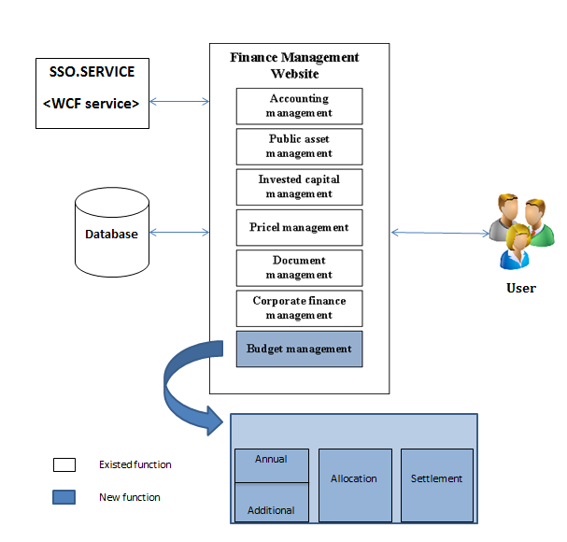

## Use Case Diagram

### 2.2.1 Overview Diagram

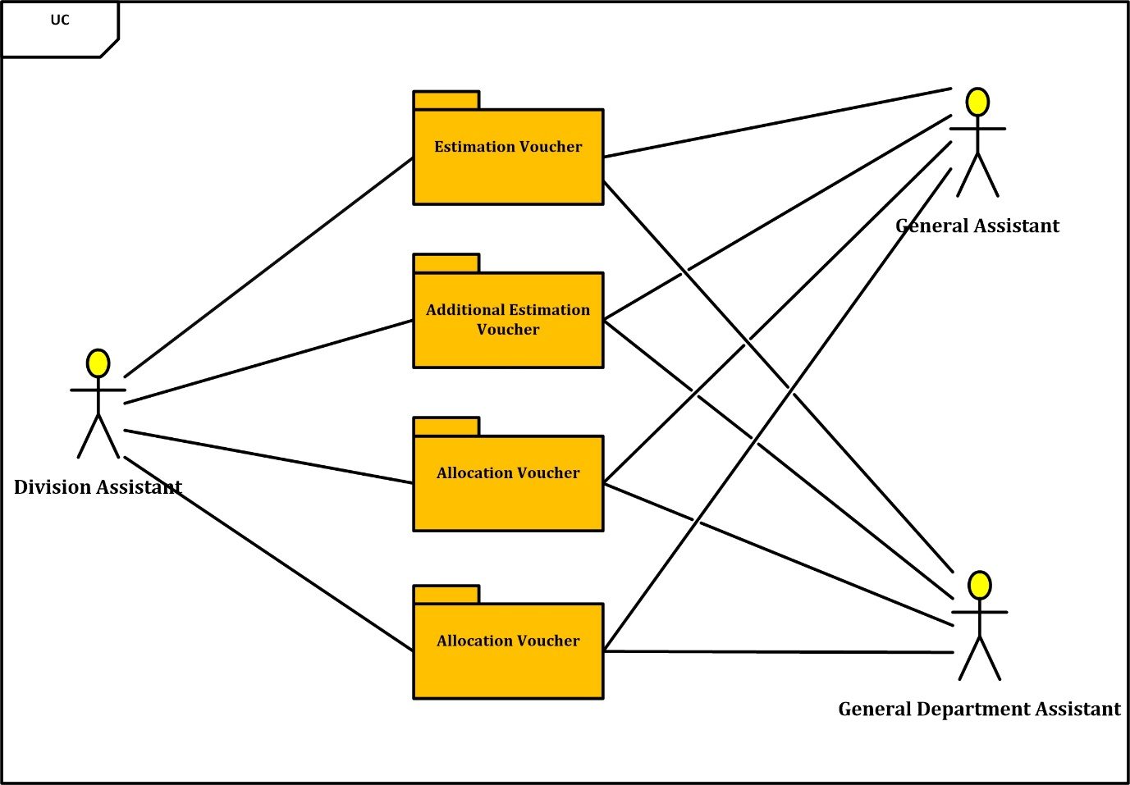

### 2.2.2 Estimation Voucher

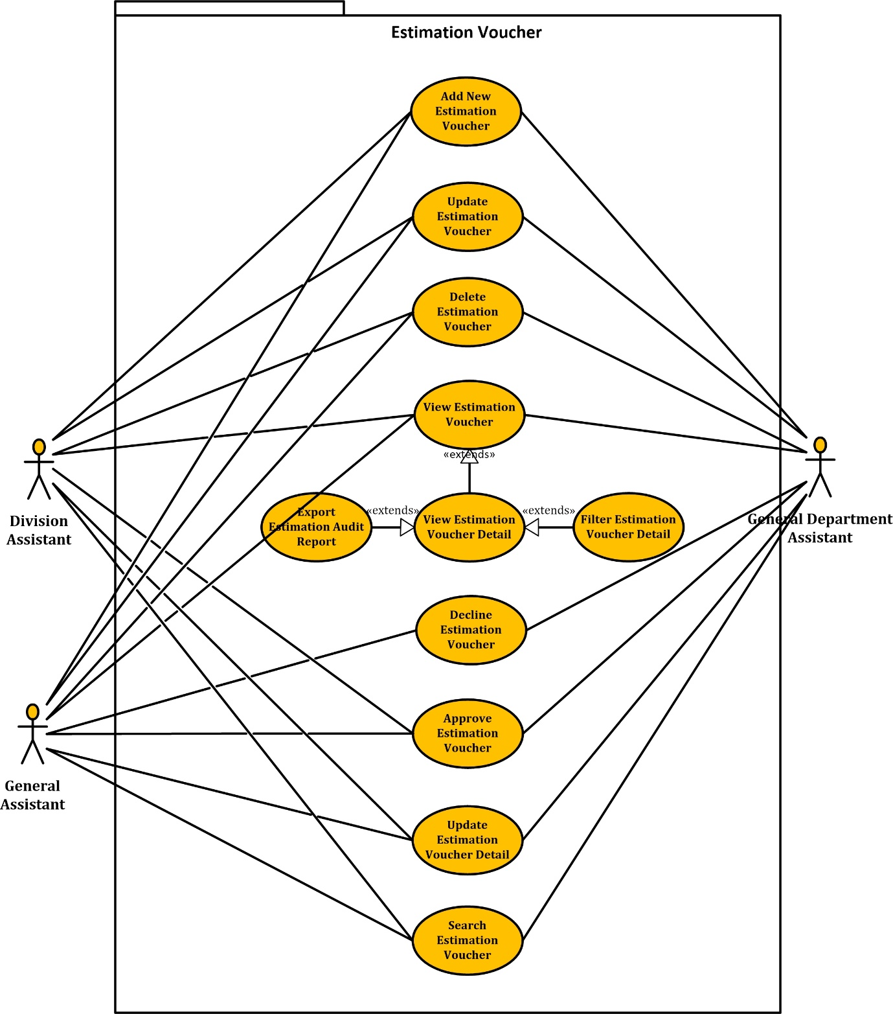

### 2.2.3 Additional Estimation Voucher

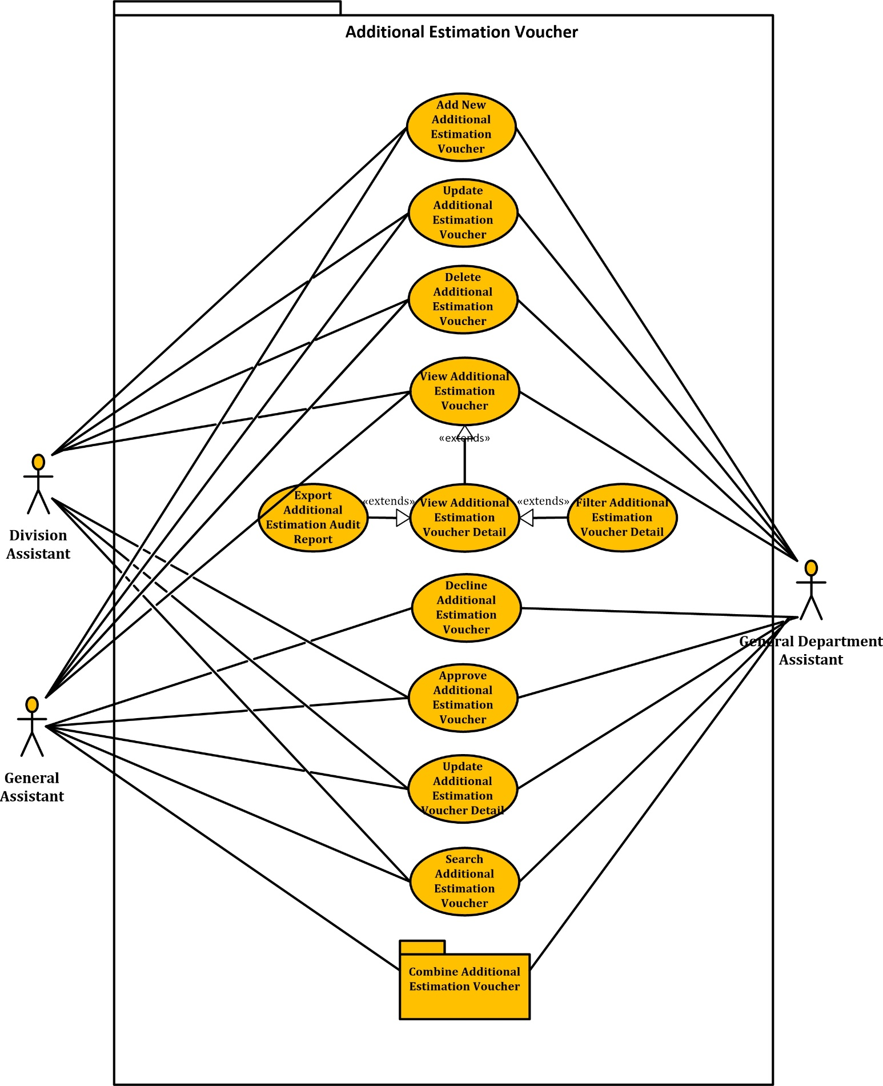

### 2.2.3.1 Combine Additional Estimation Voucher

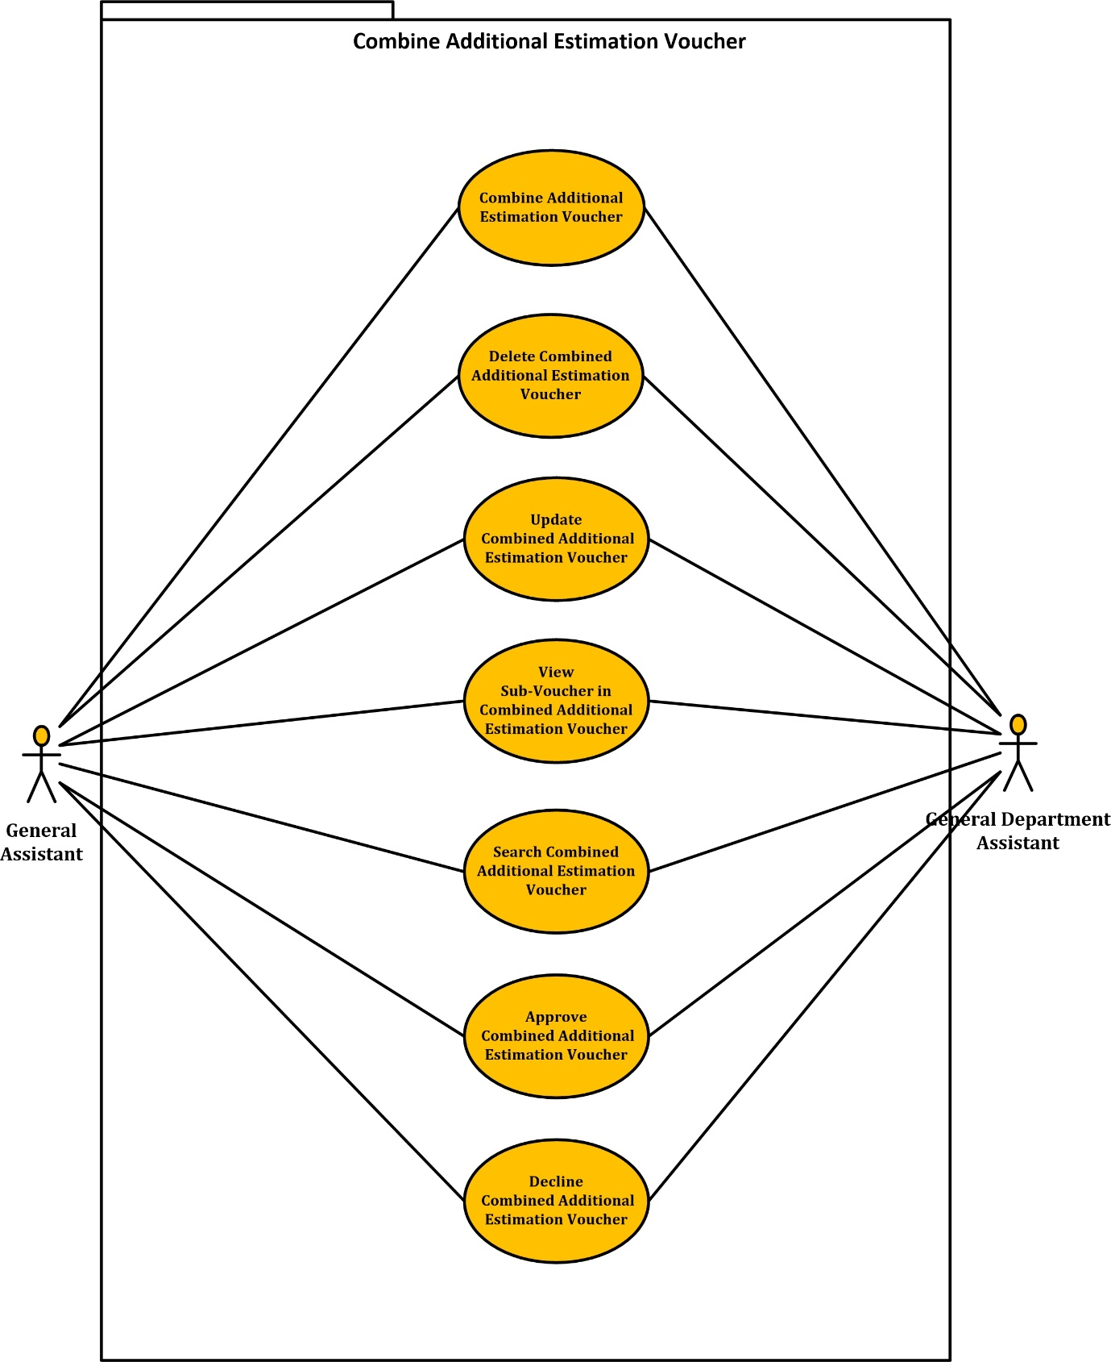

### 2.2.4 Allocation Voucher

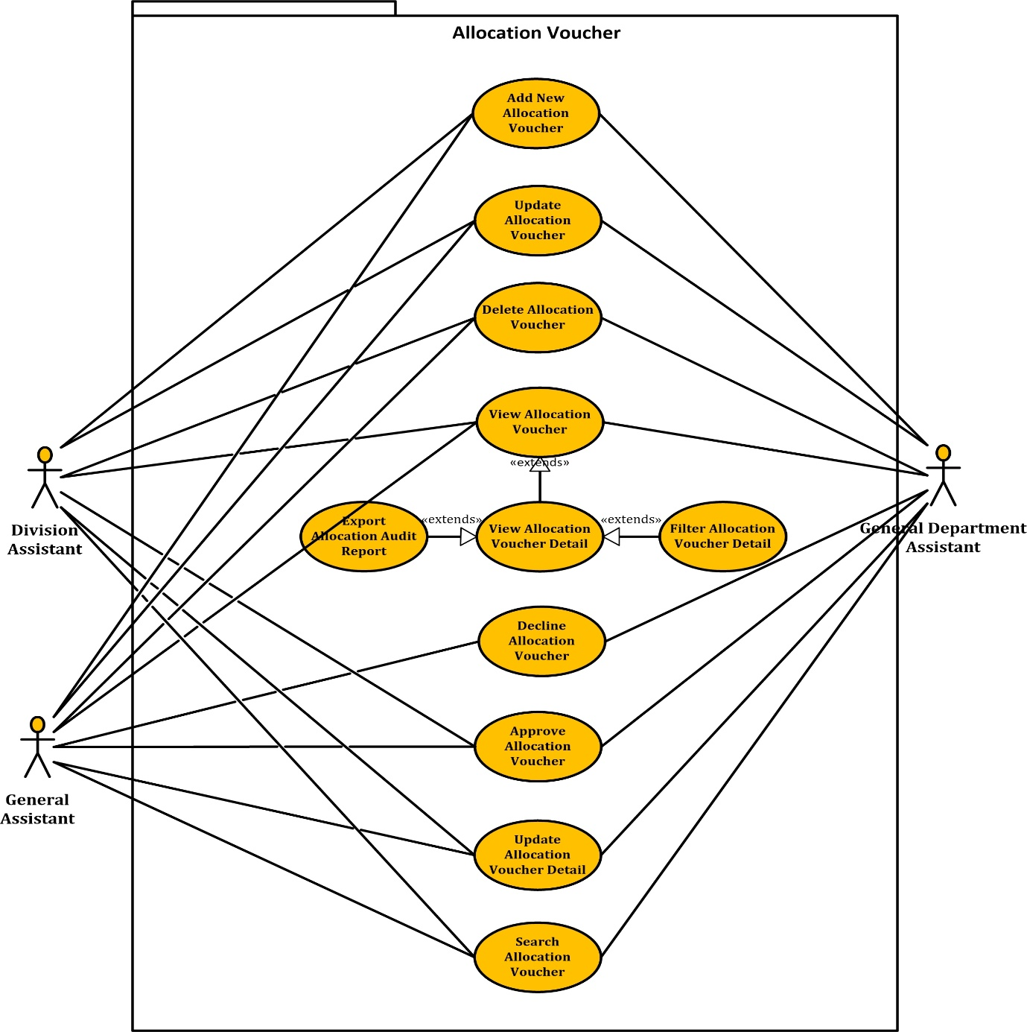

### 2.2.5 Settlement Voucher

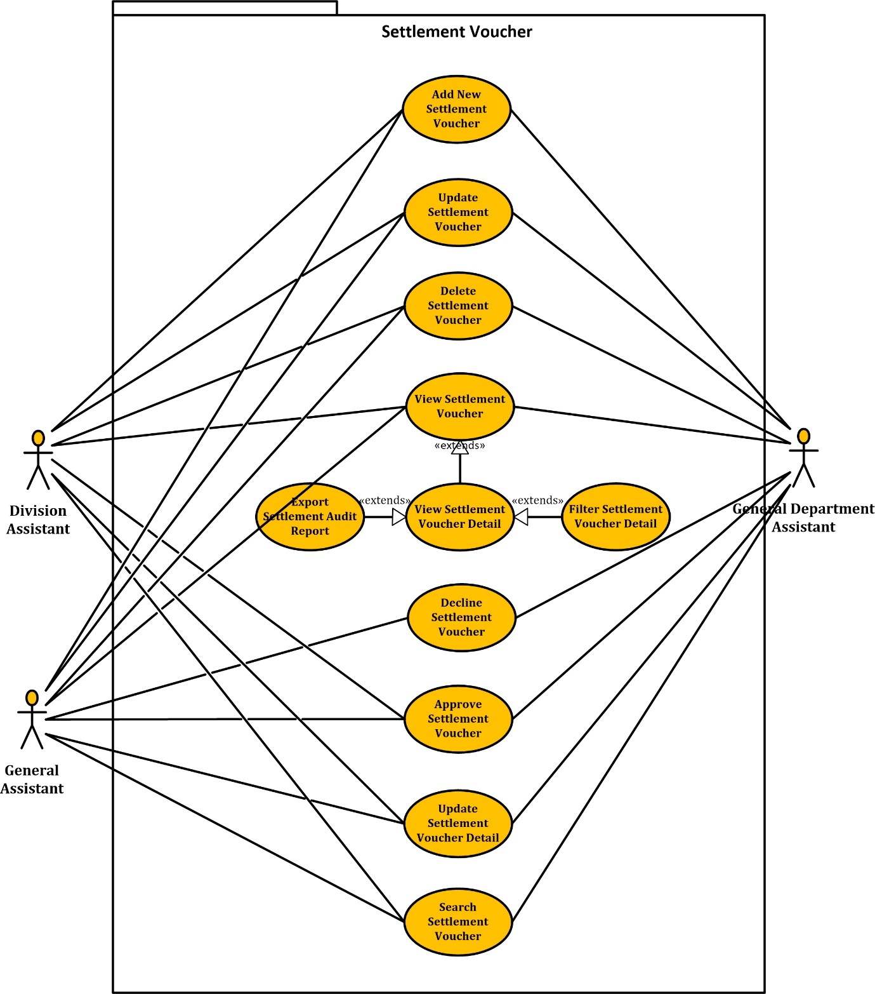

## Product Functions

|  |  |  |
| --- | --- | --- |
| **UC No.** | **Function** | **Glossary** |
| **Budget Estimation** | | |
| UC001 | Add new estimation voucher | Allow user create new estimation voucher |
| UC002 | Update estimation voucher | User edit information of an estimation voucher |
| UC003 | Delete estimation voucher | Allow user delete an estimation voucher |
| UC004 | View list estimation voucher | User can see list of all estimation vouchers |
| UC005 | Search estimation voucher | User can search estimation vouchers by budget type, date, status |
| UC006 | Update estimation voucher detail | User can edit detail data of an estimation voucher |
| UC007 | View estimation voucher detail | User can view detail data of an estimation voucher |
| UC008 | Filter estimation voucher detail information | User can filter detail’s data by budget type, section, subsection to see |
| UC009 | Approve estimation voucher | Allow user approve an additional estimation voucher |
| UC010 | Decline estimation | Allow user decline an additional estimation voucher |
| UC011 | Export “*Dự Toán - Tổng hợp dự toán chi ngân sách*” report | Allow user export a report by select phase, division, budget type, unit |
| UC012 | Export “*Báo cáo Ngân Sách bảo đảm bổ sung*” report | Allow user export a report by select phase, division, unit |
| UC013 | Export “*Chi tiêu ngân sách đảm bảo phân cấp*” report | Allow user export a report by select phase, division, branch, sheet |
| **Additional Budget Estimation** | | |
| UC014 | Add new additional estimation voucher | Allow user create new additional estimation voucher |
| UC015 | Update additional estimation voucher | User edit information of an additional estimation voucher |
| UC016 | Delete additional estimation voucher | Allow user delete an additional estimation voucher |
| UC017 | View list additional estimation voucher | User can see list of all additional estimation vouchers |
| UC018 | Search additional estimation voucher | User can search additional estimation vouchers by budget type, date, status |
| UC019 | Update additional estimation voucher detail | User can edit data of an additional estimation voucher |
| UC020 | Filter Additional Estimation Voucher Detail | User can filter detail’s data by budget type, section, subsection to see |
| UC021 | Approve additional estimation voucher | Allow user approve an additional estimation voucher |
| UC022 | Decline additional estimation voucher | Allow user decline an additional estimation voucher |
| UC023 | Export audit report | Allow user export an Audit report in additional estimation voucher’s screen by select report view point, cast unit, unit |
| UC024 | Combine additional estimation voucher | User can combine two or more additional estimation vouchers |
| UC025 | View combined additional estimation voucher | User can see one or more combined additional estimation voucher with sub-voucher by select combined voucher |
| UC026 | Search combined additional estimation vouchers | User can search combined additional estimation vouchers by date, status |
| UC027 | Update combined additional estimation voucher | User can edit sub-voucher, edit date and content information of a combined additional estimation voucher |
| UC028 | Delete combined additional estimation voucher | Allow user delete a combined additional estimation voucher |
| UC029 | Approve combined additional estimation voucher | Allow user approve a combined additional estimation voucher |
| UC030 | Decline combined voucher | Allow user decline a combined additional estimation voucher |
| UC031 | Export “*Chi tiêu ngân sách*” report | Allow user export a report by select phase, division, unit |
| UC032 | Export “*Tổng hợp dự toán chi tiêu ngân sách*” report | Allow user export a report by select phase, division, unit, date |
| UC033 | Export “*Bảng kiểm số liệu phân cấp*” report | Allow user export a report by select phase, division, unit, date |
| **Budget Allocation** | | |
| UC034 | Add new allocation voucher | Allow user create a new allocation voucher |
| UC035 | Update allocation voucher | User edit information of an allocation voucher |
| UC036 | Delete allocation voucher | Allow user delete an allocation voucher |
| UC037 | View list allocation voucher | User can see list of all allocation vouchers |
| UC038 | Search allocation voucher | User can search allocation vouchers by voucher number, date, status, allocation type |
| UC039 | Update allocation voucher detail | User can edit data of an allocation voucher |
| UC040 | View allocation voucher detail | Allow user view detail data of an allocation voucher |
| UC041 | Filter allocation voucher detail | User can filter detail’s data by budget type, section, subsection to see |
| UC042 | Approve allocation voucher | Allow user approve an allocation voucher |
| UC043 | Export “*Cấp Phát Thông Tri*” reports | Allow user export a report by select phase, Allocation type, division, unit |
| **Budget Settlement** | | |
| UC044 | Add new settlement voucher | Allow user create a new settlement voucher |
| UC045 | Update settlement voucher | User edit information of a settlement voucher |
| UC046 | Delete settlement voucher | Allow user delete a settlement voucher |
| UC047 | View list settlement voucher | User can see list of all settlement vouchers |
| UC048 | Search settlement voucher | User can search settlement vouchers by Unit, Quarter, voucher number, status, date |
| UC049 | Update settlement voucher detail | User can edit data of a settlement voucher |
| UC050 | View settlement voucher detail | Allow user view detail data of a settlement voucher |
| UC051 | Filter settlement voucher detail | User can filter detail’s data by budget type, section, subsection to see |
| UC052 | Export “*Báo cáo quyết toán LNS Đơn vị*” Report | Allow user export a report by select quarter, year, division, budget type , unit |
| UC053 | Export “*Quyết Toán Tổng Hợp*” report | Allow user export a report by select quarter, year, division, budget type , unit |
| UC054 | Export “*Quyết toán Tổng hợp nhập số liệu*” report | Allow user export a report by select quarter, year, division |
| UC055 | Export “*Quyết Toán Thông Tri*” reports | Allow user export a report by select quarter, year, division, settlement budget, unit |
| UC056 | Export “*Quyết toán chọn Đơn vị - LNS*” report | Allow user export a report by select quarter, year, division, settlement budget, unit |
| UC057 | Export “*Quyết toán tổng hợp chọn LNS*” report | Allow user export a report by select quarter, year, division, settlement budget, sheet |
| UC058 | Export “*Quyết toán tổng hợp năm - quý*” report | Allow user export a report by select quarter, year, division, settlement budget, unit |
| UC059 | Export “*Quyết toán phòng ban*” report | Allow user export a report by select quarter, year, division, settlement budget, unit |

## User Characteristic

|  |  |
| --- | --- |
| **Member** | **Description** |
| Division Assistant | A division has an account to log into system, they can use most of function which just apply with their divistion.  *Example*: Division Assistant of B-05 just can add, search, view, update and approve ... informations or vouchers of B-05 division. |
| General Assistant | In additional of division assistant's permission, they can combine , decline vouchers which their division manages |
| General Department | In additional of General assistant's permission, they can combine vouchers of all division. |
| Administrator | They have an Administrator control panel to manage all configuration of system and they can separate of permission for user's account base on role or division... |

## Assumption

* + Receive most of documents about development process.
  + Can meet stakeholder to confirm or support when need to know about division, requirement of system…
  + Server and devices are appropriate in the development process. No device got fail.
  + Has a relationship with other modules which is done before

# FUNCTIONAL SPECIFICATION

## Budget Estimation

### 3.1.1 UC001 - Add New Estimation Voucher

|  |  |  |  |
| --- | --- | --- | --- |
| **Use Case ID** | UC001 | **Version** | 1.0 |
| **Use Case Name** | Add new estimation voucher | | |
| **Create By** | QuyDQ | **Date Created** | 17/10/2015 |
| **Primary Actor** | User | **Secondary Actor** | N/A |
| **Description** | Add new voucher of estimation follow by : budget type and date time | | |
| **Preconditions** | User has already logged in system with permission adding | | |
| **Post conditions** | A new estimation voucher and its details will be created and saved in database | | |
| **Normal Flow** | 1. User select [Dự Toán] on the header of home page and click [Nhập Dự Toán NSQP] hyperlink 2. System redirect to [Dự Toán Chứng Từ] screen 3. In the [Dự Toán Chứng Từ] screen ,user tick the checkbox [Bổ sung đợt mới] 4. User select the budget type in [Loại Ngân Sách] dropdown list 5. User select date time in [Ngày tháng] calendar 6. User input content of lifecycle in [Nội dung đợt] text area 7. User click [Thêm mới] button 8. System will redirect to [Dự Toán Chứng Từ Chi Tiết] screen 9. User input value for budget column    * + Press F2 to add new row.      + Press Delete to delete value      + Press Backspace to edit value      + Press F10 to save value 10. User click [Thực hiện] button to save new voucher of estimation then redirect to [Dự Toán Chứng Từ] screen. | | |
| **Alternative Flows** | N/A | | |
| **Exceptions** | **E1: Budget type is empty**  Roll back to estimation voucher page with error message:”Bạn chưa chọn loại ngân sách, hãy chọn lại!”  **E2: Invalid date format**  Roll back to estimation voucher page with error message: “Định dạng ngày bị sai, hãy nhập theo định dạng : ngày/tháng/năm” | | |
| **Priority** | High | | |
| **Frequency of Use** | High | | |
| **Business Rules** | B1, B2, B5, B9 | | |

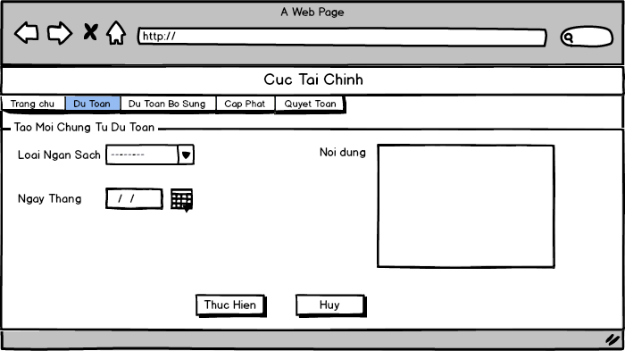

*Add new estimation voucher*

### 3.1.2 UC002 - Update Estimation Voucher

|  |  |  |  |
| --- | --- | --- | --- |
| **Use Case ID** | UC002 | **Version** | 1.0 |
| **Use Case Name** | Update estimation voucher | | |
| **Create By** | QuyDQ | **Date Created** | 17/10/2015 |
| **Primary Actor** | User | **Secondary Actor** | N/A |
| **Description** | Update budget type, content and date time of estimation voucher | | |
| **Preconditions** | User has already logged in system with permission editing | | |
| **Post conditions** | Estimation voucher will be edited information | | |
| **Normal Flow** | 1. User select [Dự Toán] on the header of home page and click [Nhập Dự Toán NSQP] hyperlink 2. System redirect to [Dự Toán Chứng Từ] screen, estimation voucher is listed in [Danh sách đợt dự toán] table 3. User click [Sửa] button of estimation voucher that want to edit 4. System redirect to [Sửa thông tin chứng từ] screen 5. User click calendar icon to change date time of estimation voucher 6. User update content in [Nội dung] text area 7. User click [Lưu] button to save estimation voucher 8. System redirect to [Dự Toán Chứng Từ] screen | | |
| **Alternative Flows** | **In step 7,**  User click [Hủy] button to cancel edit estimation voucher and then system go back [Dự Toán Chứng Từ] screen | | |
| **Exceptions** | **E1: Invalid date format**  Display error message : “Định dạng ngày bị sai, hãy nhập theo định dạng : ngày/tháng/năm” | | |
| **Priority** | Medium | | |
| **Frequency of Use** | Normal | | |
| **Business Rules** | B4 | | |

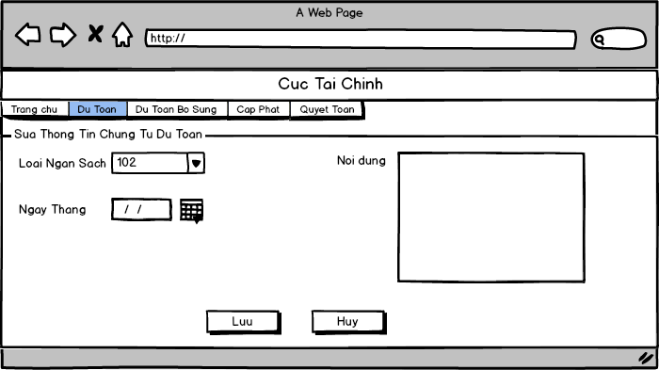

*Update estimation voucher*

### 3.1.3 UC003 - Delete Estimation Voucher

|  |  |  |  |
| --- | --- | --- | --- |
| **Use Case ID** | UC003 | **Version** | 1.0 |
| **Use Case Name** | Delete estimation voucher | | |
| **Create By** | QuyDQ | **Date Created** | 17/10/2015 |
| **Primary Actor** | User | **Secondary Actor** | N/A |
| **Description** | Delete estimation voucher and its detail in database | | |
| **Preconditions** | User has already logged in system with permission deleting | | |
| **Post conditions** | Estimation voucher will be deleted and removed in list table | | |
| **Normal Flow** | 1. User select [Dự Toán] on the header of home page and click [Nhập Dự Toán NSQP] hyperlink 2. System redirect to [Dự Toán Chứng Từ] screen, estimation voucher is listed in [Danh sách đợt dự toán] table 3. User click [Xóa] button of estimation voucher that want to delete 4. System will display popup to confirm 5. User click [Ok] button to delete estimation voucher 6. System closes popup, reloads page and Estimation voucher will be removed from [Danh sách đợt dự toán] table | | |
| **Alternative Flows** | **In step 5,**   1. User click [Hủy] to cancel request. 2. Popup will be closed 3. Estimation voucher does not change | | |
| **Exceptions** | N/A | | |
| **Priority** | High | | |
| **Frequency of Use** | Normal | | |
| **Business Rules** | N/A | | |

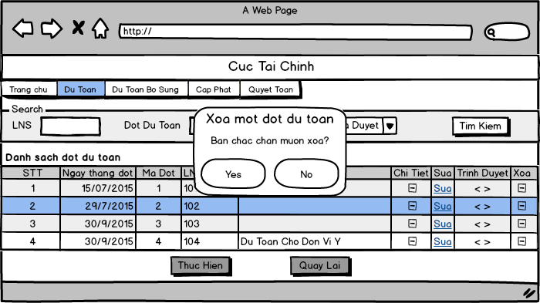

*Delete estimation voucher*

### 3.1.4 UC004 - View List Estimation Voucher

|  |  |  |  |
| --- | --- | --- | --- |
| **Use Case ID** | UC004 | **Version** | 1.0 |
| **Use Case Name** | View list estimation voucher | | |
| **Create By** | QuyDQ | **Date Created** | 17/10/2015 |
| **Primary Actor** | User | **Secondary Actor** | N/A |
| **Description** | View list all of estimation voucher in table | | |
| **Preconditions** | User has already logged in system with permission viewing | | |
| **Post conditions** | Display list of existed voucher | | |
| **Normal Flow** | 1. User select [Dự Toán] on the header of home page and click [Nhập Dự Toán NSQP] hyperlink 2. System redirect to [Dự Toán Chứng Từ] screen, estimation voucher is listed in [Danh sách đợt dự toán] table | | |
| **Alternative Flows** | N/A | | |
| **Exceptions** | N/A | | |
| **Priority** | High | | |
| **Frequency of Use** | High | | |
| **Business Rules** | B3 | | |

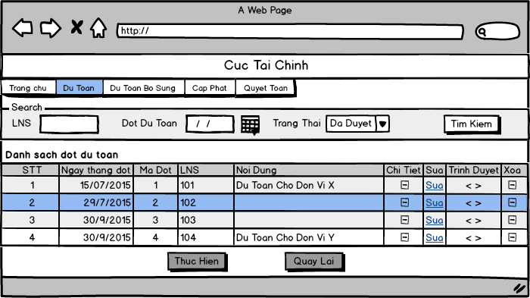

*View estimation voucher*

### 3.1.5 UC005 - Search Estimation Voucher

|  |  |  |  |
| --- | --- | --- | --- |
| **Use Case ID** | UC005 | **Version** | 1.0 |
| **Use Case Name** | Search estimation voucher | | |
| **Create By** | QuyDQ | **Date Created** | 17/10/2015 |
| **Primary Actor** | User | **Secondary Actor** | N/A |
| **Description** | Search estimation voucher follow by : budget type, lifecycle or status | | |
| **Preconditions** | User has already logged in system | | |
| **Post conditions** | The search result is displayed in table | | |
| **Normal Flow** | 1. User select [Dự Toán] on the header of home page and click [Nhập Dự Toán NSQP] hyperlink 2. System redirect to [Dự Toán Chứng Từ] screen 3. User select one or more condition to search    * + Select budget type from [Chọn LNS] drop-down list to search by budget type      + Select date time from [Đợt dự toán từ] calendar and [Đến ngày] calendar to search by lifecycle date time      + Select status from [Trạng Thái] drop-down list to search by status 4. User click on [Tìm kiếm] button to search 5. System displays result in [Danh sách đợt dự toán] table | | |
| **Alternative Flows** | N/A | | |
| **Exceptions** | **E1 - User select date time in [Đợt từ ngày] < [Đến ngày]**  The message will be display to alert error | | |
| **Priority** | High | | |
| **Frequency of Use** | High | | |
| **Business Rules** | B6, B7, B8 | | |

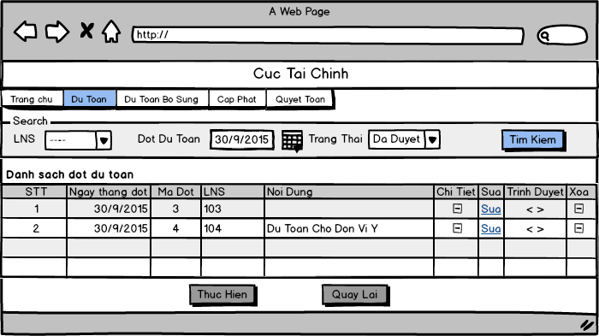

*Search estimation voucher*

### 3.1.6 UC006 - Update Estimation Voucher Detail

|  |  |  |  |
| --- | --- | --- | --- |
| **Use Case ID** | UC006 | **Version** | 1.0 |
| **Use Case Name** | Update estimation voucher detail | | |
| **Create By** | QuyDQ | **Date Created** | 17/10/2015 |
| **Primary Actor** | User | **Secondary Actor** | N/A |
| **Description** | Update data of estimation voucher detail | | |
| **Preconditions** | User has already logged in system with permission editing | | |
| **Post conditions** | The chosen estimation voucher detail is updated | | |
| **Normal Flow** | 1. User select [Dự Toán] on the header of home page and click [Nhập Dự Toán NSQP] hyperlink 2. System redirect to [Dự Toán Chứng Từ] screen, estimation voucher is listed in [Danh sách đợt dự toán] table 3. User click [Chi Tiết] button to view estimation voucher detail 4. System redirect to [Dự Toán Chứng Từ Chi Tiết] screen 5. User enters information of estimation voucher detail 6. System checks for keyword validation. It deletes all those invalid keyword after user enters it. 7. User click [Thực hiện] button to save new voucher of estimation 8. System redirect to [Dự Toán Chứng Từ] screen. | | |
| **Alternative Flows** | **In step 3,**  If user click button [Quay Lại] ,system redirects to estimation voucher page | | |
| **Exceptions** | N/A | | |
| **Priority** | High | | |
| **Frequency of Use** | High | | |
| **Business Rules** | B5 | | |

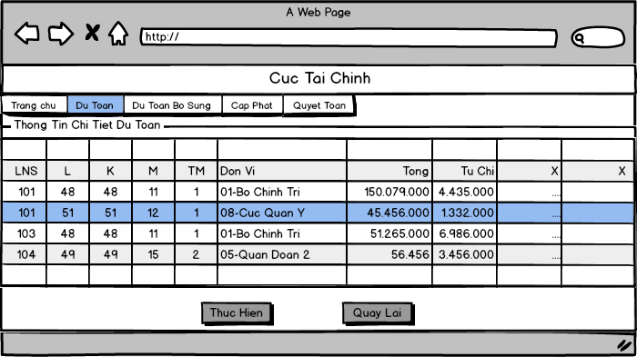

*Update estimation voucher detail*

### 3.1.7 UC007 - View Estimation Voucher Detail

|  |  |  |  |
| --- | --- | --- | --- |
| **Use Case ID** | UC007 | **Version** | 1.0 |
| **Use Case Name** | View estimation voucher detail | | |
| **Create By** | QuyDQ | **Date Created** | 17/10/2015 |
| **Primary Actor** | User | **Secondary Actor** | N/A |
| **Description** | View estimation voucher detail and user can sort by input data | | |
| **Preconditions** | User has already logged in system with permission viewing | | |
| **Post conditions** | Display estimation voucher detail in the [Dự Toán Chứng Từ Chi Tiết] screen | | |
| **Normal Flow** | 1. User select [Dự Toán] on the header of home page and click [Nhập Dự Toán NSQP] hyperlink 2. System redirect to [Dự Toán Chứng Từ] screen, estimation voucher is listed in [Danh sách đợt dự toán] table 3. User click [Chi Tiết] button to view estimation voucher detail 4. System redirect to [Dự Toán Chứng Từ Chi Tiết] screen | | |
| **Alternative Flows** | **After step 3 ,**   1. User click [Tùy chỉnh] button and then a popup [Tùy chỉnh] will be displayed    * + Select [Tất cả mục ngân sách] from [Chọn Tùy Chỉnh] dropdown list to view all data in estimation voucher detail      + Select [ Hiện dự toán đã nhập] from [Chọn Tùy Chỉnh] dropdown list to view all data that was inputed in estimation voucher detail      + Select [ Hiện dự toán chưa nhập] from [Chọn Tùy Chỉnh] dropdown list to view all data that was not inputted in estimation voucher detail 2. Popup will be closed | | |
| **Exceptions** | N/A | | |
| **Priority** | High | | |
| **Frequency of Use** | High | | |
| **Business Rules** | N/A | | |



*View estimation voucher detail*

### 3.1.8 UC008 - Filter Estimation Voucher Detail

|  |  |  |  |
| --- | --- | --- | --- |
| **Use Case ID** | UC008 | **Version** | 1.0 |
| **Use Case Name** | Filter estimation voucher detail | | |
| **Create By** | QuyDQ | **Date Created** | 17/10/2015 |
| **Primary Actor** | User | **Secondary Actor** | N/A |
| **Description** | Filter the estimation voucher detail by budget type, section, subsection… | | |
| **Preconditions** | User has already logged in system with permission | | |
| **Post conditions** | The filtering result is displayed in [Dự Toán Chứng Từ Chi Tiết] screen | | |
| **Normal Flow** | 1. User select [Dự Toán] on the header of home page and click [Nhập Dự Toán NSQP] hyperlink 2. System redirect to [Dự Toán Chứng Từ] screen, estimation voucher is listed in [Danh sách đợt dự toán] table 3. User click [Chi Tiết] button to view estimation voucher detail 4. System redirect to [Dự Toán Chứng Từ Chi Tiết] screen 5. User enters budget type or section ,subsection… to be filtered 6. System reloads the estimation voucher detail grid and display the filtered information | | |
| **Alternative Flows** | N/A | | |
| **Exceptions** | N/A | | |
| **Priority** | Medium | | |
| **Frequency of Use** | Medium | | |
| **Business Rules** | B5 | | |

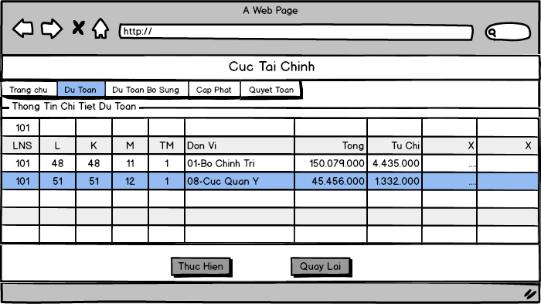

*Filter estimation voucher detail*

### 3.1.9 UC009 - Approve Estimation Voucher

|  |  |  |  |
| --- | --- | --- | --- |
| **Use Case ID** | UC009 | **Version** | 1.0 |
| **Use Case Name** | Approve estimation voucher | | |
| **Create By** | QuyDQ | **Date Created** | 17/10/2015 |
| **Primary Actor** | User | **Secondary Actor** | N/A |
| **Description** | Approve estimation voucher to general handle | | |
| **Preconditions** | User has already logged in system with permission approving | | |
| **Post conditions** | Estimation voucher will be approved and changed status of voucher | | |
| **Normal Flow** | 1. User select [Dự Toán] on the header of home page click [Nhập Dự Toán NSQP] hyperlink 2. System redirect to [Dự Toán Chứng Từ] screen, estimation voucher is listed in [Danh sách đợt dự toán] table 3. User click [Approve] button of estimation voucher that want to approve 4. System will display popup [Duyệt chứng từ] to confirm 5. User input reason in [Lý do] text area 6. User click [Tiếp tục] button to approve estimation voucher 7. Popup will be closed   9. Estimation voucher will be changed status on [Danh sách đợt dự toán] table | | |
| **Alternative Flows** | **In any steps after step 3,**   1. User click [Chi tiết] button of estimation voucher that want to approve   5. System will redirect to [Dự Toán Chứng Từ Chi Tiết] screen   1. User click [Trình Duyệt] on the button 2. System will display popup [Duyệt chứng từ] to confirm 3. Input reason in [Lý do] text area 4. User click [Tiếp tục] button to approve estimation voucher 5. Popup will be closed 6. Estimation voucher will be changed status on [Danh sách đợt dự toán] table   **In step 7 ,**  7. User clicks [Hủy] to cancel request.   1. Popup will be closed 2. Estimation voucher does not change | | |
| **Exceptions** | N/A | | |
| **Priority** | High | | |
| **Frequency of Use** | High | | |
| **Business Rules** | N/A | | |

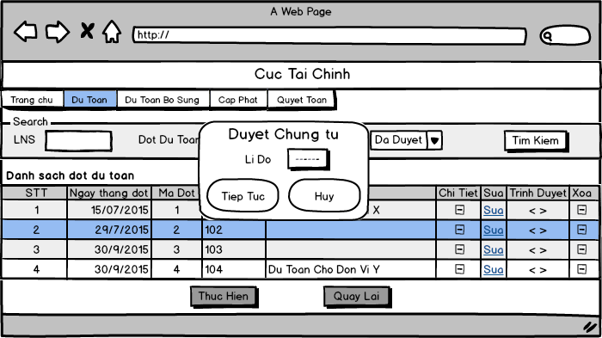

*Approve estimation voucher*

### 3.1.10 UC010 - Decline Estimation Voucher

|  |  |  |  |
| --- | --- | --- | --- |
| **Use Case ID** | UC010 | **Version** | 1.0 |
| **Use Case Name** | Decline estimation voucher | | |
| **Create By** | QuyDQ | **Date Created** | 17/10/2015 |
| **Primary Actor** | User | **Secondary Actor** | N/A |
| **Description** | Decline estimation voucher and assistant must check again | | |
| **Preconditions** | User has already logged in system with permission declining | | |
| **Post conditions** | Estimation voucher will be declined and changed status | | |
| **Normal Flow** | 1. User select [Dự Toán] on the header of home page and click [Nhập Dự Toán NSQP] hyperlink 2. System redirect to [Dự Toán Chứng Từ] screen, estimation voucher is listed in [Danh sách đợt dự toán] table 3. User click [Decline] button of estimation voucher that want to decline 4. System will display popup [Từ chối chứng từ] to confirm 5. User input reason in [Lý do] text area 6. User click [Tiếp tục] button to approve estimation voucher 7. Popup will be closed 8. Estimation voucher will be changed status on [Danh sách đợt dự toán] table | | |
| **Alternative Flows** | **In step 7 ,**   1. User clicks [Hủy] to cancel request. 2. Popup will be closed 3. Estimation voucher does not change | | |
| **Exceptions** | N/A | | |
| **Priority** | High | | |
| **Frequency of Use** | High | | |
| **Business Rules** | N/A | | |

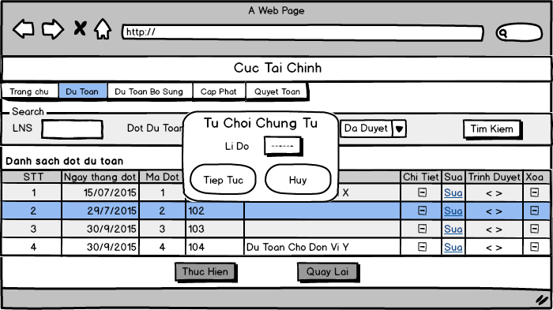

*Decline estimation voucher*

### 3.1.11 UC011 - Export “*Tổng hợp dự toán chi ngân sách*” Report

|  |  |  |  |
| --- | --- | --- | --- |
| **Use Case ID** | UC011 | **Version** |  |
| **Use Case Name** | Export “*Tổng hợp dự toán chi ngân sách*” report | | |
| **Create By** | HungPH | **Date Created** | 20/10/2015 |
| **Primary Actor** | User | **Secondary Actor** |  |
| **Description** | User select condition to export “*Tổng hợp dự toán chi ngân sách*” report with information they want | | |
| **Preconditions** | User has already logged in System  User has permission to export report | | |
| **Post conditions** | The report which they want to view had created | | |
| **Normal Flow** | 1. Select [Quyết Toán] on the header of home page and click [Dự Toán đơn vị] hyperlink 2. System redirect to [Danh sách báo cáo] screen 3. User click [Tổng hợp dự toán chi ngân sách] hyperlink 4. User redirect to [Tổng hợp dự toán chi ngân sách] report screen 5. User select all condition to export report  * Select phase from [Chọn Đợt] drop-down list * Select Division from [Chọn phòng ban] drop-down list  1. User select one or more budget kind from [Loại Ngân Sách] check list which display base on all condition selected before (Phase, Division) 2. User select one or more Unit from [Chọn đơn vị] check list which display base on all condition selected before (Phase,, Division, budget kind) 3. User choose kind report  * Select [Chi Tiết ĐV] or [Tổng Hợp ĐV] to export general report or export report for each Unit (default [Chi Tiết ĐV])  1. User click [Thực Hiện] button to create report 2. Report had created and show in new browsers tab | | |
| **Alternative Flows** | **In step 8, user click [Hủy] button**  System redirect to [Danh sách báo cáo] screen | | |
| **Exceptions** | **E1 – No select budget kind**  A message “*Chưa chọn loại ngân sách*”  **E2 – No select Unit**  A message “*Chưa chọn đơn vị*” | | |
| **Priority** | High | | |
| **Frequency of Use** | High | | |
| **Business Rules** | B2, B10 | | |

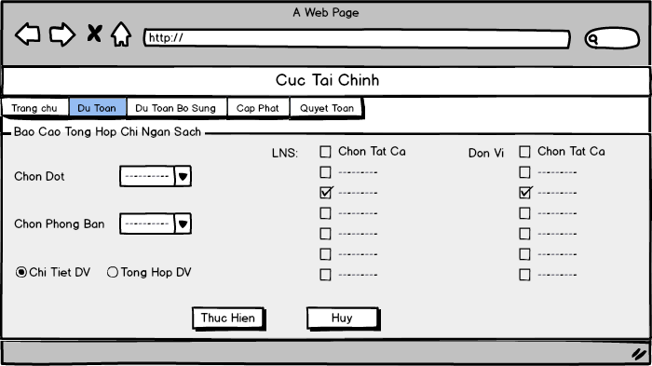

*“Tổng hợp dự toán chi ngân sách” report screen*

### 3.1.12 UC012 - Export “*Báo cáo Ngân Sách bảo đảm bổ sung*” Report

|  |  |  |  |
| --- | --- | --- | --- |
| **Use Case ID** | UC012 | **Version** |  |
| **Use Case Name** | Export “*Báo cáo Ngân Sách bảo đảm bổ sung*” report | | |
| **Create By** | HungPH | **Date Created** | 24/10/2015 |
| **Primary Actor** | User | **Secondary Actor** |  |
| **Description** | User select condition to export “*Báo cáo Ngân Sách bảo đảm bổ sung*” report with information they want | | |
| **Preconditions** | User has already logged in System  User has permission to export report | | |
| **Post conditions** | The report which they want to view had created | | |
| **Normal Flow** | 1. Select [Dự Toán] on the header of home page and click [Dự Toán đơn vị] hyperlink 2. System redirect to [Danh sách báo cáo] screen 3. Click [Báo cáo Ngân Sách bảo đảm bổ sung] hyperlink 4. System redirect to [Báo cáo Ngân Sách bảo đảm bổ sung] report screen 5. User select all condition to export report  * Select phase from [Chọn Đợt] drop-down list * Select Division from [Chọn phòng ban] drop-down list * Select [Chi Tiết ĐV] or [Tổng Hợp ĐV] to export general report or export report for each Unit (default [Chi Tiết ĐV]) * Select one or more Unit from [Chọn đơn vị] check list which display base on all condition selected before (Phase,, Division, budget kind  1. User click [Thực Hiện] button to create report 2. Report had created and show in new browsers tab | | |
| **Alternative Flows** | **In step 6, user click [Hủy] button**  System redirect to [Danh sách báo cáo] screen | | |
| **Exceptions** | **E1 – No select Unit**  A message “*Chưa chọn đơn vị*” | | |
| **Priority** | High | | |
| **Frequency of Use** | High | | |
| **Business Rules** | B10 | | |

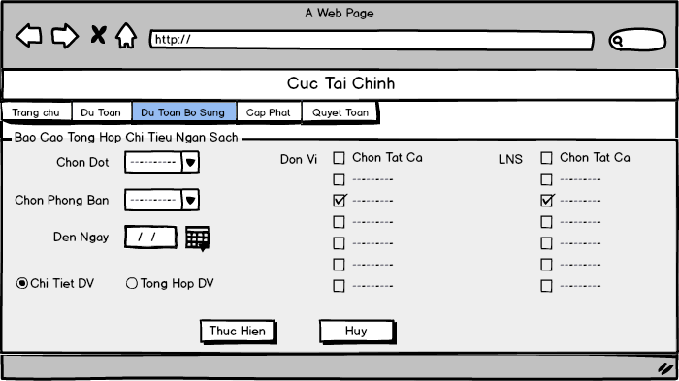

*“Báo cáo Ngân Sách bảo đảm bổ sung” report screen*

### 3.1.13 UC013 - Export “Chi tiêu ngân sách đảm bảo phân cấp” Report

|  |  |  |  |
| --- | --- | --- | --- |
| **Use Case ID** | UC013 | **Version** |  |
| **Use Case Name** | Export “*Chi tiêu ngân sách đảm bảo phân cấp*” report | | |
| **Create By** | HungPX | **Date Created** | 20/10/2015 |
| **Primary Actor** | User | **Secondary Actor** | N/A |
| **Description** |  | | |
| **Preconditions** | User has already logged in System  User has permission to export report | | |
| **Post conditions** | “*Chi tiêu ngân sách đảm bảo phân cấp*” report is exported | | |
| **Normal Flow** | 1. User clicks on [Dự toán] hyperlink on header home page and click [ Danh sách báo cáo] 2. System redirect to [Danh sách báo cáo] screen. 3. User clicks on [Chi tiêu ngân sách đảm bảo phân cấp] hyperlink 4. System redirects to [Chi tiêu ngân sách đảm bảo phân cấp] screen. 5. User selects all conditions to export the report:  * Select budgetary session in [Đợt] dropdown list * Select department in [phòng ban] dropdown list * Select branch in [ngành] dropdown list.  1. System shows the Sheet in [Tờ] list of check box depend on the selected user options. 2. User select Sheet in [Tờ] list of check box and click [Tiếp Tục] button 3. System exports the report in new page. | | |
| **Alternative Flows** | **In step 7. User clicks on [Hủy] button instead of [Tiếp tục] button**   1. User click on [Hủy] button 2. System redirects to [Danh sách báo cáo] screen. | | |
| **Exceptions** | **N/A** | | |
| **Priority** | High | | |
| **Frequency of Use** | High | | |
| **Business Rules** | B13 | | |

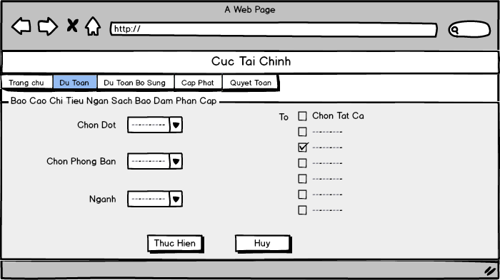

*“Chi tiêu ngân sách đảm bảo phân cấp” report screen*

## Additional Budget Estimation

### 3.2.1 UC014 - Add New Additional Estimation Voucher

|  |  |  |  |
| --- | --- | --- | --- |
| **Use Case ID** | UC014 | **Version** | 1.0 |
| **Use Case Name** | Add new additional estimation voucher | | |
| **Create By** | TuNB | **Date Created** | 17/10/2015 |
| **Primary Actor** | User | **Secondary Actor** | N/A |
| **Description** | Use can create new additional estimation voucher to add information of estimation to database | | |
| **Preconditions** | User has already logged in system  User have permission to create new additional estimation voucher | | |
| **Post conditions** | A new additional estimation voucher and its details will be created and save in database | | |
| **Normal Flow** | 1. Select [Dự Toán bổ sung] on the header of home page and click [Nhập Dự Toán NSQP] hyperlink 2. System redirect to [Dự Toán Chứng Từ] screen 3. User tick the checkbox [Bổ sung đợt mới] in the [Dự Toán Chứng Từ] screen 4. User select one or more budget type in [Loại Ngân Sách] list checkbox 5. User select source of budget type in [Nguồn Ngân Sách] dropdown list 6. User select date time in [Ngày tháng] calendar 7. User input content of lifecycle in [Nội dung đợt] text are 8. User click [Thêm mới] button 9. System will redirect to [Dự Toán Chứng Từ Chi Tiết] screen 10. Input value for budget column     * Press F2 to add new row.     * Press Delete to delete value     * Press Backspace to edit value     * Press F10 to save value 11. User click [Thực hiện] button 12. System save new voucher of additional estimation then redirect to [Dự Toán Chứng Từ] screen. | | |
| **Alternative Flows** | **In step 2-6**, User uncheck [Bổ sung đợt mới] check box, BMS hidden add new panel | | |
| **Exceptions** | **E1: Budget type is empty**  Roll back to additional estimation voucher page with error message  **E2: Invalid date format**  Roll back to additional estimation voucher page with error message | | |
| **Priority** | High | | |
| **Frequency of Use** | High | | |
| **Business Rules** | B2, B9 | | |

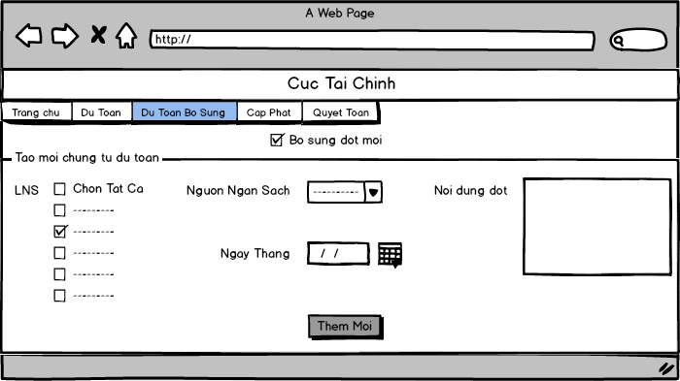

*Add new additional estimation voucher*

### 3.2.2 UC015 - Update Additional Estimation Voucher

|  |  |  |  |
| --- | --- | --- | --- |
| **Use Case ID** | UC015 | **Version** | 1.0 |
| **Use Case Name** | Update additional estimation voucher | | |
| **Create By** | TuNB | **Date Created** | 17/10/2015 |
| **Primary Actor** | User | **Secondary Actor** | N/A |
| **Description** | User can update information of voucher when voucher has change | | |
| **Preconditions** | User has already logged in system  User has permission to edit  At least one additional estimation voucher created before | | |
| **Post conditions** | Additional estimation voucher will be edited information and save in database | | |
| **Normal Flow** | 1. Select [Dự Toán bổ sung] on the header of home page and Click [Nhập Dự Toán NSQP] hyperlink 2. System redirect to [Dự Toán Chứng Từ] screen, estimation voucher is listed in [Danh sách đợt dự toán bổ sung] table 3. User click [Sửa] button of estimation voucher that want to edit 4. System redirect to [Sửa thông tin chứng từ] screen 5. User click calendar icon to change date time of estimation voucher 6. User update content in [Nội dung] text area : 7. User click [Lưu] button 8. System save estimation voucher and then system redirect to [Dự Toán Chứng Từ] screen | | |
| **Alternative Flows** | User click button [Hủy] before save  BMS back to additional estimation voucher page | | |
| **Exceptions** | **E1: Invalid date format**  Display error message | | |
| **Priority** | High | | |
| **Frequency of Use** | Normal | | |
| **Business Rules** | B9 | | |

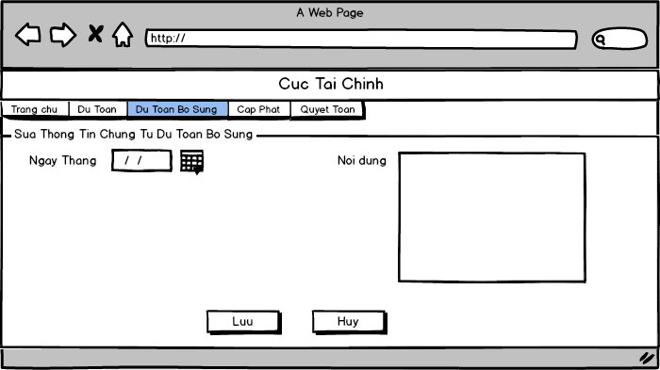

*Update additional estimation voucher*

### 3.2.3 UC016 - Delete Additional Estimation Voucher

|  |  |  |  |
| --- | --- | --- | --- |
| **Use Case ID** | UC016 | **Version** | 1.0 |
| **Use Case Name** | Delete additional estimation voucher | | |
| **Create By** | TuNB | **Date Created** | 17/10/2015 |
| **Primary Actor** | User | **Secondary Actor** | N/A |
| **Description** | User can delete a additional estimation voucher | | |
| **Preconditions** | User has already logged in system  User has permission to delete  At least one additional estimation voucher created before | | |
| **Post conditions** | Additional estimation voucher will be deleted and removed in list table | | |
| **Normal Flow** | 1. User select [Dự Toán bổ sung] on the header of home page and click [Nhập Dự Toán NSQP] hyperlink 2. System redirect to [Dự Toán Chứng Từ] screen, estimation voucher is listed in [Danh sách đợt dự toán bổ sung] table 3. User click [Xóa] button of additional estimation voucher that want to delete 4. System will display popup to confirm 5. User click [Ok] button to delete additional estimation voucher 6. Popup will be closed 7. System reloads page and additional estimation voucher will be removed from [Danh sách đợt dự toán bổ sung] table | | |
| **Alternative Flows** | **In step 5,**   1. Click [Hủy] to cancel request. 2. Popup will be closed 3. Estimation voucher does not change | | |
| **Exceptions** | N/A | | |
| **Priority** | High | | |
| **Frequency of Use** | Normal | | |
| **Business Rules** |  | | |

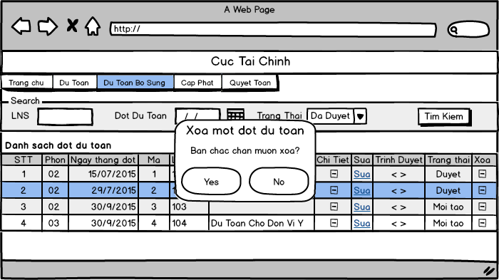

*Delete additional estimation voucher*

### 3.2.4 UC017 - View List Additional Estimation Voucher

|  |  |  |  |
| --- | --- | --- | --- |
| **Use Case ID** | UC017 | **Version** | 1.0 |
| **Use Case Name** | View list additional estimation voucher | | |
| **Create By** | TuNB | **Date Created** | 17/10/2015 |
| **Primary Actor** | User | **Secondary Actor** | N/A |
| **Description** | User can view list of all additional estimation vouchers | | |
| **Preconditions** | User has already logged in system  User has permission to view | | |
| **Post conditions** | Display list of existed voucher | | |
| **Normal Flow** | 1. User select [Dự Toán bố sung] on the header of home page and click [Nhập Dự Toán NSQP] hyperlink 2. System redirect to [Dự Toán Chứng Từ] screen, estimation voucher is listed in [Danh sách đợt dự toán bổ sung] table | | |
| **Alternative Flows** | N/A | | |
| **Exceptions** | N/A | | |
| **Priority** | High | | |
| **Frequency of Use** | High | | |
| **Business Rules** |  | | |

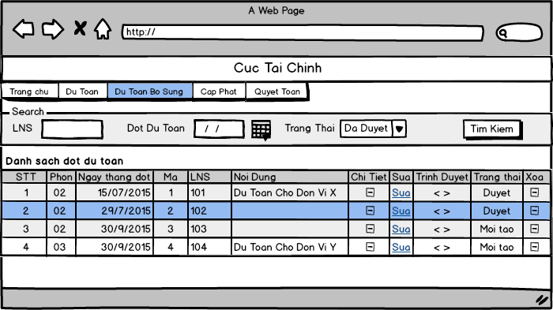

*View list additional estimation voucher*

### 3.2.5 UC018 - Search Additional Estimation Voucher

|  |  |  |  |
| --- | --- | --- | --- |
| **Use Case ID** | UC018 | **Version** | 1.0 |
| **Use Case Name** | Search additional estimation voucher | | |
| **Create By** | TuNB | **Date Created** | 17/10/2015 |
| **Primary Actor** | User | **Secondary Actor** | N/A |
| **Description** | User can search voucher with one or more condition: budget type, date time, status | | |
| **Preconditions** | User has already logged in system | | |
| **Post conditions** | Display list of vouchers which user want to view | | |
| **Normal Flow** | 1. Select [Dự Toán bổ sung] on the header of home page and click [Nhập Dự Toán NSQP] hyperlink  2. System redirect to [Dự Toán Chứng Từ] screen   1. User select one or more condition to search    * + Select budget type from [Chọn LNS] drop-down list to search by budget type      + Select date time from [Đợt dự toán từ] calendar and [Đến ngày] calendar to search by lifecycle date time      + Select status from [Trạng Thái] drop-down list to search by status 2. User click on [Tìm kiếm] button to search 3. System displays result in [Danh sách đợt dự toán bổ sung] table | | |
| **Alternative Flows** | N/A | | |
| **Exceptions** | N/A | | |
| **Priority** | High | | |
| **Frequency of Use** | Medium | | |
| **Business Rules** | B6, B7, B8 | | |

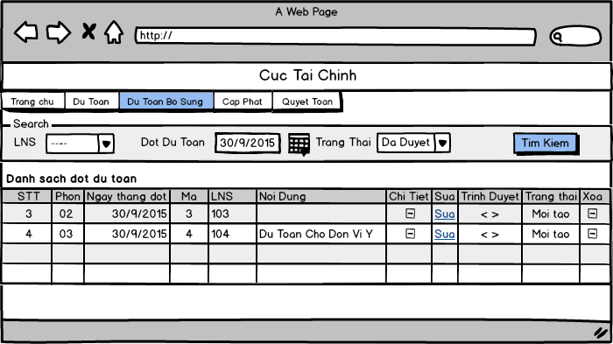

*Search additional estimation voucher*

### 3.2.6 UC019 - Update Additional Estimation Voucher Detail

|  |  |  |  |
| --- | --- | --- | --- |
| **Use Case ID** | UC019 | **Version** | 1.0 |
| **Use Case Name** | Update additional estimation voucher detail | | |
| **Create By** | TuNB | **Date Created** | 17/10/2015 |
| **Primary Actor** | User | **Secondary Actor** | N/A |
| **Description** | User can update additional estimation voucher’s detail | | |
| **Preconditions** | User has already logged in system  User has permission to edit detail | | |
| **Post conditions** | Additional estimation voucher’s detail will be updated and save in database | | |
| **Normal Flow** | 1. User select [Dự Toán bổ sung] on the header of home page and click [Nhập Dự Toán NSQP] hyperlink 2. System redirect to [Dự Toán Chứng Từ] screen, estimation voucher is listed in [Danh sách đợt dự toán bổ sung] table 3. User click [Chi Tiết] button to view estimation voucher detail 4. System redirect to [Dự Toán Chứng Từ Chi Tiết] screen 5. User enters information of estimation voucher detail 6. System checks for keyword validation. It deletes all those invalid keyword after user enters it. 7. User click [Thực hiện] button 8. System save new voucher of estimation then redirect to [Dự Toán Chứng Từ] screen. | | |
| **Alternative Flows** | **In step 3,**  If user click button [Quay Lại] ,system redirects to additional estimation voucher page | | |
| **Exceptions** | N/A | | |
| **Priority** | High | | |
| **Frequency of Use** | High | | |
| **Business Rules** | B5 | | |

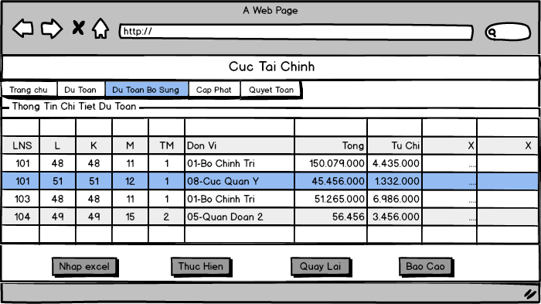

*Update additional estimation voucher detail*

### 3.2.7 UC020 - Filter Additional Estimation Voucher Detail

|  |  |  |  |
| --- | --- | --- | --- |
| **Use Case ID** | UC020 | **Version** | 1.0 |
| **Use Case Name** | Filter additional estimation voucher detail | | |
| **Create By** | TuNB | **Date Created** | 17/10/2015 |
| **Primary Actor** | User | **Secondary Actor** | N/A |
| **Description** | User can filter detail information of voucher by budget type, section, subsection… | | |
| **Preconditions** | User has already logged in system  At least one voucher has detail information created before | | |
| **Post conditions** | The filtering result is displayed to view | | |
| **Normal Flow** | 1. User select [Dự Toán bổ sung] on the header of home page and click [Nhập Dự Toán NSQP] hyperlink 2. System redirect to [Dự Toán Chứng Từ] screen, additional estimation voucher is listed in [Danh sách đợt dự toán bổ sung] table 3. Click [Chi Tiết] button to view additional estimation voucher detail 4. System redirect to [Dự Toán Chứng Từ Chi Tiết] screen 5. User enters budget type or section ,subsection… to be filtered 6. System reloads the additional estimation voucher detail grid and display the filtered information | | |
| **Alternative Flows** | N/A | | |
| **Exceptions** | N/A | | |
| **Priority** | High | | |
| **Frequency of Use** | High | | |
| **Business Rules** | N/A | | |

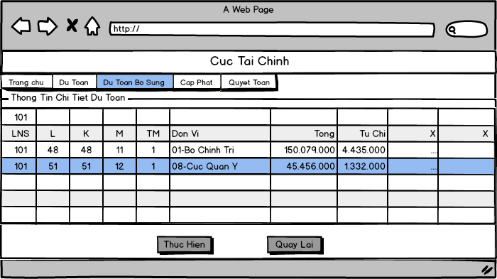

*Filter additional estimation voucher detail*

### 3.2.8 UC021 - Approve Additional Estimation Voucher

|  |  |  |  |
| --- | --- | --- | --- |
| **Use Case ID** | UC021 | **Version** | 1.0 |
| **Use Case Name** | Approve additional estimation voucher | | |
| **Create By** | TuNB | **Date Created** | 17/10/2015 |
| **Primary Actor** | User | **Secondary Actor** | N/A |
| **Description** | User can approve a additional estimation voucher | | |
| **Preconditions** | User has already logged in system  User has permission approve  At least one voucher created before | | |
| **Post conditions** | Additional estimation voucher will be approved and changed status of voucher | | |
| **Normal Flow** | 1. User select [Dự Toán bổ sung] on the header of home page and click [Nhập Dự Toán NSQP] hyperlink 2. System redirect to [Dự Toán Chứng Từ] screen, additional estimation voucher is listed in [Danh sách đợt dự toán bổ sung] table 3. User click [Approve] button of additional estimation voucher that want to approve 4. System will display popup [Duyệt chứng từ] to confirm 5. User input reason in [Lý do] text area 6. User click [Tiếp tục] button to approve additional estimation voucher 7. Popup will be closed 8. Estimation voucher will be changed status on [Danh sách đợt dự toán bổ sung] table | | |
| **Alternative Flows** | **In any steps after step 2,**   1. Click [Chi tiết] button of estimation voucher that want to approve 2. System will redirect to [Dự Toán Chứng Từ Chi Tiết] screen 3. Click [Trình Duyệt] on the button 4. System will display popup [Duyệt chứng từ] to confirm 5. Input reason in [Lý do] text area 6. Click [Tiếp tục] button to approve estimation voucher 7. Popup will be closed 8. Estimation voucher will be changed status on [Danh sách đợt dự toán bổ sung] table   **In step 6 ,**   1. Click [Hủy] to cancel request. 2. Popup will be closed 3. Estimation voucher does not change | | |
| **Exceptions** | N/A | | |
| **Priority** | Medium | | |
| **Frequency of Use** | High | | |
| **Business Rules** | N/A | | |

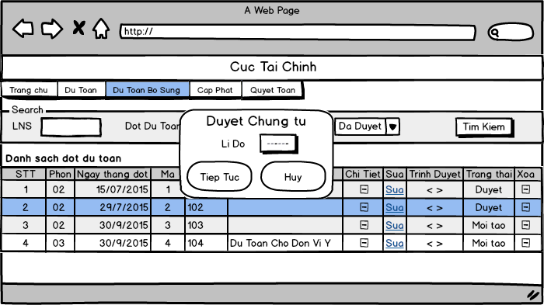

*Approve additional estimation voucher*

### 3.2.9 UC022 - Decline additional estimation Voucher

|  |  |  |  |
| --- | --- | --- | --- |
| **Use Case ID** | UC022 | **Version** | 1.0 |
| **Use Case Name** | Decline additional estimation voucher | | |
| **Create By** | TuNB | **Date Created** | 17/10/2015 |
| **Primary Actor** | User | **Secondary Actor** | N/A |
| **Description** | User can decline an additional estimation voucher | | |
| **Preconditions** | User has already logged in system  User has permission to decline  At least one voucher created before | | |
| **Post conditions** | Additional estimation voucher will be declined and changed status | | |
| **Normal Flow** | 1. Select [Dự Toán bổ sung] on the header of home page and click [Nhập Dự Toán NSQP] hyperlink 2. System redirect to [Dự Toán Chứng Từ] screen, estimation voucher is listed in [Danh sách đợt dự toán bổ sung] table 3. User click [Decline] button of estimation voucher that want to decline 4. System will display popup [Từ chối chứng từ] to confirm 5. Input reason in [Lý do] text area 6. User click [Tiếp tục] button to decline estimation voucher 7. Popup will be closed 8. Estimation voucher will be changed status on [Danh sách đợt dự toán bổ sung] table | | |
| **Alternative Flows** | **In step 6 ,**  7. Click [Hủy] to cancel request.   1. Popup will be closed 2. Estimation voucher does not change | | |
| **Exceptions** | N/A | | |
| **Priority** | Medium | | |
| **Frequency of Use** | High | | |
| **Business Rules** | N/A | | |

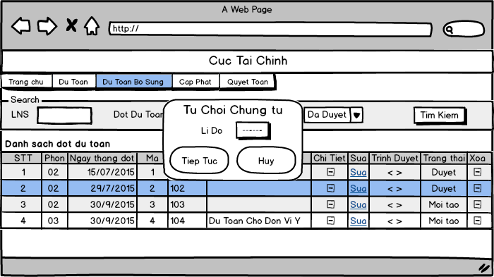

*Decline additional estimation voucher*

### 3.2.10 UC023 - Export Audit Report

|  |  |  |  |
| --- | --- | --- | --- |
| **Use Case ID** | UC023 | **Version** | 1.0 |
| **Use Case Name** | Export audit report | | |
| **Create By** | TuNB | **Date Created** | 17/10/2015 |
| **Primary Actor** | User | **Secondary Actor** | N/A |
| **Description** | User can export audit report when they see detail information of voucher | | |
| **Preconditions** | User access to additional estimation voucher page  User has permission to export report | | |
| **Post conditions** | The report will be create and display in another browse tab | | |
| **Normal Flow** | 1. User click detail hyperlink from list voucher Table 2. System redirect to voucher detail page 3. User click button [Báo Cáo] button 4. System display a popup 5. User select report view point from combobox 6. User select cash unit from combobox 7. User select units from list checkbox 8. User click button [Tiếp Tục] in popup 9. System export report in new tab | | |
| **Alternative Flows** | In step 4-8, User click button [Hủy] in popup  BMS hide popup and do nothing | | |
| **Exceptions** | E1: unit is empty, user don’t select any unit  Output error message | | |
| **Priority** | Medium | | |
| **Frequency of Use** | Medium | | |
| **Business Rules** | B10 | | |

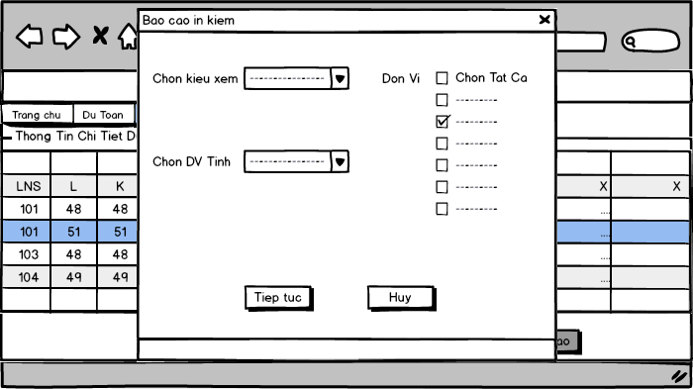

*Export audit report*

### 3.2.11 UC024 - Combine Additional Estimation Voucher

|  |  |  |  |
| --- | --- | --- | --- |
| **Use Case ID** | UC024 | **Version** | 1.0 |
| **Use Case Name** | Combine voucher in Additional Estimation | | |
| **Create By** | TuNB | **Date Created** | 17/10/2015 |
| **Primary Actor** | User | **Secondary Actor** | N/A |
| **Description** | User combine two or more voucher by select | | |
| **Preconditions** | User has already logged in system  User has permission to combine  At least two voucher created before | | |
| **Post conditions** | New combined voucher will be created and save to database | | |
| **Normal Flow** | 1. User select [Dự Toán bổ sung] on the header of home page and click [Gom Đợt Dự Toán NSQP] hyperlink 2. System redirect to [Gom Đợt Dự Toán] screen 3. User tick the checkbox [Bổ sung đợt mới] 4. User tick one or more lifecycle in [Chọn Đợt] list checkbox to add lifecycle that want to combine 5. User select date time in [Ngày tháng] calendar to set date 6. User input content of lifecycle in [Nội dung đợt] text area 7. User click [Thêm mới] button 8. System create new voucher that combined selected voucher 9. System reload additional estimation voucher combine page | | |
| **Alternative Flows** | N/A | | |
| **Exceptions** | **E1: No voucher selected**  Display error message  **E2: Invalid date format**  Display error message | | |
| **Priority** | High | | |
| **Frequency of Use** | High | | |
| **Business Rules** | B9 | | |

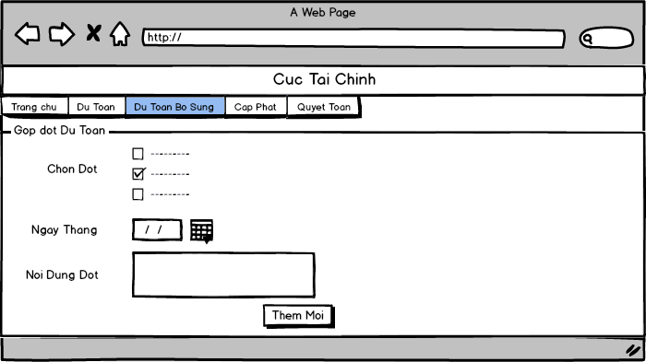

*Combine voucher in Additional Estimation*

### 3.2.12 UC025 - View sub-voucher in Combined Additional Estimation

|  |  |  |  |
| --- | --- | --- | --- |
| **Use Case ID** | UC025 | **Version** | 1.0 |
| **Use Case Name** | View combined voucher | | |
| **Create By** | TuNB | **Date Created** | 17/10/2015 |
| **Primary Actor** | User | **Secondary Actor** | N/A |
| **Description** | View list sub-voucher of a combined voucher | | |
| **Preconditions** | User has already logged in system  User has permission to view  At least one combine voucher created before | | |
| **Post conditions** | List all sub-voucher of a combined voucher | | |
| **Normal Flow** | 1. User select [Dự Toán bổ sung] on the header of home page and click [Gom Đợt Dự Toán NSQP] hyperlink 2. System redirect to [Gom Đợt Dự Toán] screen, combined voucher is listed in [Danh sách đợt dự toán bổ sung tổng hợp] table 3. User click [Chi Tiết] button or hyperlink in list combined voucher table 4. System go to sub-voucher page 5. System display all sub-voucher of selected combined voucher | | |
| **Alternative Flows** | N/A | | |
| **Exceptions** | N/A | | |
| **Priority** | High | | |
| **Frequency of Use** | High | | |
| **Business Rules** | N/A | | |

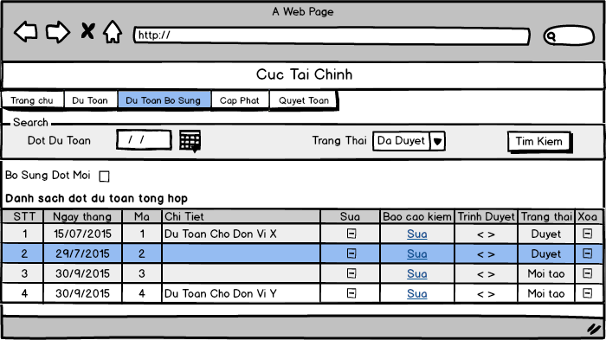

*View combined voucher*

### 3.2.13 UC026 - Search combined Additional Estimation Voucher

|  |  |  |  |
| --- | --- | --- | --- |
| **Use Case ID** | UC026 | **Version** | 1.0 |
| **Use Case Name** | Search combined voucher | | |
| **Create By** | TuNB | **Date Created** | 17/10/2015 |
| **Primary Actor** | User | **Secondary Actor** | N/A |
| **Description** | User search combined vouchers with condition: date time, status | | |
| **Preconditions** | User has already logged in system | | |
| **Post conditions** | Display list of vouchers which user want to view | | |
| **Normal Flow** | 1. User select [Dự Toán bổ sung] on the header of home page and click [Gom Đợt Dự Toán NSQP] hyperlink 2. System redirect to [Gom Đợt Dự Toán] screen 3. User select one or more condition to search 4. User select date time from [Đợt dự toán từ] calendar and [Đến ngày] calendar to search by lifecycle date time 5. Use select status from [Trạng Thái] drop-down list to search by status 6. User click on [Tìm kiếm] button to search 7. System displays result in [Danh sách đợt dự toán bổ sung tổng hợp] table | | |
| **Alternative Flows** | N/A | | |
| **Exceptions** | N/A | | |
| **Priority** | High | | |
| **Frequency of Use** | High | | |
| **Business Rules** | B6, B7 | | |

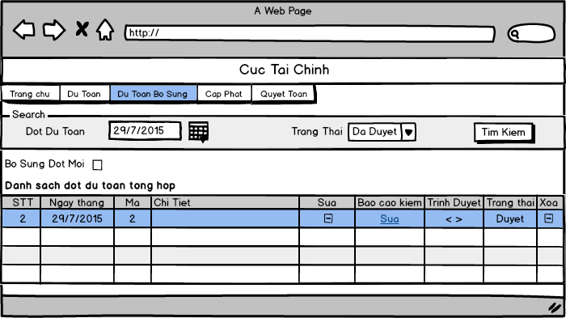

*Search combined voucher*

### 3.2.14 UC027 - Update Combined Additional Estimation Voucher

|  |  |  |  |
| --- | --- | --- | --- |
| **Use Case ID** | UC027 | **Version** | 1.0 |
| **Use Case Name** | Update combined voucher | | |
| **Create By** | TuNB | **Date Created** | 17/10/2015 |
| **Primary Actor** | User | **Secondary Actor** | N/A |
| **Description** | User can update information of voucher when voucher has change | | |
| **Preconditions** | User has already logged in system  User has permission to edit detail | | |
| **Post conditions** | Combined voucher will be updated and save to database | | |
| **Normal Flow** | 1. User select [Dự Toán bổ sung] on the header of home page click [Gom Đợt Dự Toán NSQP] hyperlink 2. System redirect to [Gom Đợt Dự Toán] screen, combined voucher is listed in [Danh sách đợt dự toán bổ sung tổng hợp] table 3. User click [Sửa] button of combined voucher that want to edit and then system redirect to [Sửa thông tin chứng từ] screen 4. User tick one or more lifecycle in [Chọn Đợt] list checkbox to change combined voucher 5. User click calendar icon to change date time of combined voucher 6. User update content in [Nội dung] text area : 7. User click [Lưu] button to save combined voucher and then system redirect to [Gom Đợt Dự Toán] screen | | |
| **Alternative Flows** | **In step 7,**  Click [Hủy] button to cancel edit combined voucher and then system go back [Gom Đợt Dự Toán] screen | | |
| **Exceptions** | **E1: No sub-voucher selected**  Display error message  **E2: Invalid date format**  Display error message | | |
| **Priority** | High | | |
| **Frequency of Use** | Normal | | |
| **Business Rules** | B9, B11 | | |

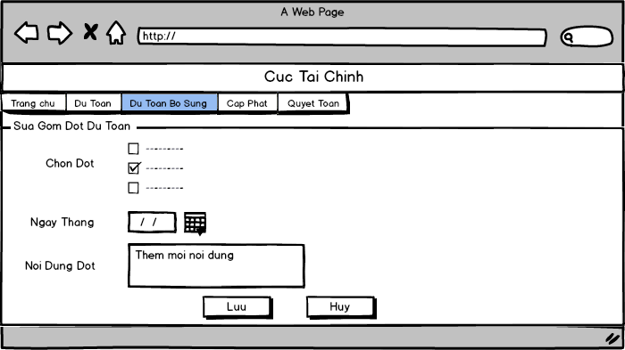

*Update combined voucher*

### 3.2.15 UC028 - Delete Combined Additional Estimation Voucher

|  |  |  |  |
| --- | --- | --- | --- |
| **Use Case ID** | UC028 | **Version** | 1.0 |
| **Use Case Name** | Delete combined voucher | | |
| **Create By** | TuNB | **Date Created** | 17/10/2015 |
| **Primary Actor** | User | **Secondary Actor** | N/A |
| **Description** | User can delete a additional estimation voucher | | |
| **Preconditions** | User has already logged in system  User has permission to delete  At least one combined voucher created before | | |
| **Post conditions** | Combined voucher will be deleted and removed in list table | | |
| **Normal Flow** | 1. User select [Dự Toán bổ sung] on the header of home page and click [Gom Đợt Dự Toán NSQP] hyperlink 2. System redirect to [Gom Đợt Dự Toán] screen, combined voucher is listed in [Danh sách đợt dự toán bổ sung tổng hợp] table 3. User click [Xóa] button of combined voucher that want to delete 4. System will display popup to confirm 5. User click [Ok] button to delete combined voucher 6. Popup will be closed 7. System reloads page and combined voucher will be removed from [Danh sách đợt dự toán bổ sung tổng hợp] table | | |
| **Alternative Flows** | **In step 5,**  6. Click [Hủy] to cancel request.  7. Popup will be closed   1. Combined voucher does not change | | |
| **Exceptions** | N/A | | |
| **Priority** | High | | |
| **Frequency of Use** | Normal | | |
| **Business Rules** | N/A | | |

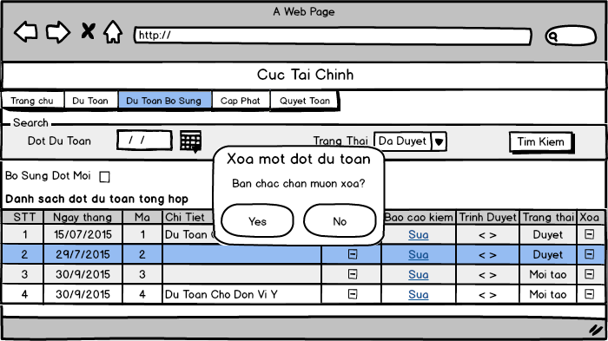

*Delete combined voucher*

### 3.2.16 UC029 - Approve Combined Additional Estimation Voucher

|  |  |  |  |
| --- | --- | --- | --- |
| **Use Case ID** | UC029 | **Version** | 1.0 |
| **Use Case Name** | Approve combined voucher | | |
| **Create By** | TuNB | **Date Created** | 17/10/2015 |
| **Primary Actor** | User | **Secondary Actor** | N/A |
| **Description** | User can approve a combined additional estimation voucher | | |
| **Preconditions** | User has already logged in system  User has permission approve  At least one voucher created before | | |
| **Post conditions** | Additional estimation voucher will be approved and changed status of voucher | | |
| **Normal Flow** | 1. User select [Dự Toán bổ sung] on the header of home page and click [Gom Đợt Dự Toán NSQP] hyperlink 2. System redirect to [Gom Đợt Dự Toán] screen, combined voucher is listed in [Danh sách đợt dự toán bổ sung tổng hợp] table 3. User click [Approve] button of combined voucher that want to approve 4. System will display popup [Duyệt chứng từ] to confirm 5. User input reason in [Lý do] text area 6. User click [Tiếp tục] button to approve combined voucher 7. Popup will be closed 8. Combined voucher will be changed status on [Danh sách đợt dự toán bổ sung tổng hợp] table | | |
| **Alternative Flows** | **In step 6 ,**  7. Click [Hủy] to cancel request.  8. Popup will be closed  9. Combined voucher does not change | | |
| **Exceptions** | N/A | | |
| **Priority** | Medium | | |
| **Frequency of Use** | High | | |
| **Business Rules** | N/A | | |

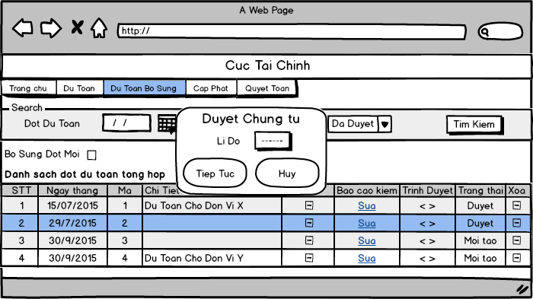

*Approve combined voucher*

### 3.2.17 UC030 - Decline Combined Additional Estimation Voucher

|  |  |  |  |
| --- | --- | --- | --- |
| **Use Case ID** | UC030 | **Version** | 1.0 |
| **Use Case Name** | Decline combined voucher | | |
| **Create By** | TuNB | **Date Created** | 17/10/2015 |
| **Primary Actor** | User | **Secondary Actor** | N/A |
| **Description** | User can decline a combined additional estimation voucher | | |
| **Preconditions** | User has already logged in system  User has permission to decline  At least one voucher created before | | |
| **Post conditions** | Combined voucher will be declined and changed status | | |
| **Normal Flow** | 1. User select [Dự Toán bổ sung] on the header of home page and click [Gom Đợt Dự Toán NSQP] hyperlink 2. System redirect to [Gom Đợt Dự Toán] screen, combined voucher is listed in [Danh sách đợt dự toán bổ sung tổng hợp] table 3. User click [Decline] button of combined voucher that want to decline 4. System will display popup [Từ chối chứng từ] to confirm 5. User input reason in [Lý do] text area 6. User click [Tiếp tục] button to decline combined voucher 7. Popup will be closed 8. Combined voucher will be changed status on [Danh sách đợt dự toán bổ sung tổng hợp] table | | |
| **Alternative Flows** | **In step 6 ,**  7. Click [Hủy] to cancel request.  8. Popup will be closed  9. Combined voucher does not change | | |
| **Exceptions** | N/A | | |
| **Priority** | Medium | | |
| **Frequency of Use** | High | | |
| **Business Rules** | N/A | | |

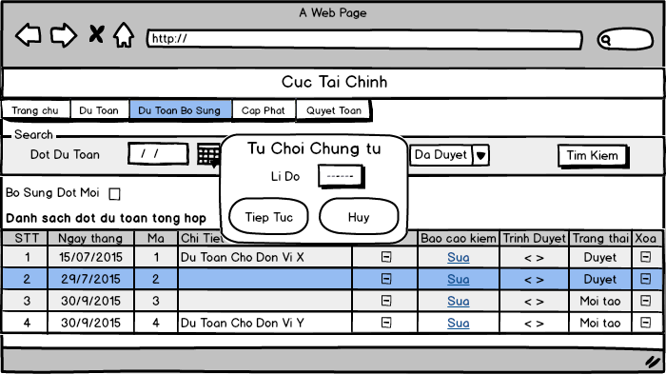

*Decline combined voucher*

### 3.2.18 UC031 - Export “*Chi tiêu ngân sách*” Report

|  |  |  |  |
| --- | --- | --- | --- |
| **Use Case ID** | UC031 | **Version** |  |
| **Use Case Name** | Export “*Chi tiêu ngân sách*” report | | |
| **Create By** | HungPX | **Date Created** | 20/10/2015 |
| **Primary Actor** | User | **Secondary Actor** | N/A |
| **Description** | User export a report name “*Chi tiêu ngân sách*” after choose condition for report’s information | | |
| **Preconditions** | User has already logged in System  User has permission to export report  Have additional estimation’s data in database from vouchers | | |
| **Post conditions** | “*Chi tiêu ngân sách*” report is exported and display in another browse tab | | |
| **Normal Flow** | 1. User selects [Dự toán bổ sung] on the header of home page and click [Danh sách báo cáo] hyperlink 2. System redirect to [Danh sách báo cáo] screen 3. User clicks on [Báo cáo chỉ tiêu ngân sách] hyperlink 4. System redirects to [Báo cáo chỉ tiêu ngân sách] screen. 5. User selects budgetary session in [đợt] dropdown list and department in [phòng ban] dropdown list 6. System shows the Units in [Đơn vị] list of check box depend on the selected user options. 7. User select Units in [Đơn vị] list of check box 8. System shows the budgetary type in [đơn vị] list of check box depend on the selected user options. 9. User click on [Thực hiện] button 10. System exports the report in new page. | | |
| **Alternative Flows** | **In step 9. User clicks on [Hủy] button instead of [Thực hiện] button**   1. User click on [Hủy] button 2. System redirects to [Danh sách báo cáo] page. | | |
| **Exceptions** | **N/A** | | |
| **Priority** | High | | |
| **Frequency of Use** | High | | |
| **Business Rules** | B2, B10 | | |

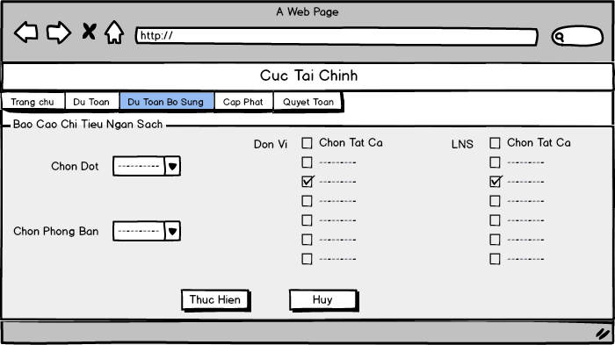

*“Chi tiêu ngân sách” report screen*

### 3.2.19 UC032 - Export “*Tổng hợp dự toán chi tiêu ngân sách*” Report

|  |  |  |  |
| --- | --- | --- | --- |
| **Use Case ID** | UC032 | **Version** |  |
| **Use Case Name** | Export “*Tổng hợp dự toán chi tiêu ngân sách*” report | | |
| **Create By** | HungPX | **Date Created** | 20/10/2015 |
| **Primary Actor** | User | **Secondary Actor** | N/A |
| **Description** | User export a report name “*Tổng hợp dự toán chi tiêu ngân sách*” after choose condition for report’s information | | |
| **Preconditions** | User has already logged in System  User has permission to export report  Have additional estimation’s data in database from vouchers | | |
| **Post conditions** | “*Tổng hợp dự toán chi tiêu ngân sách*” report is exported and display in another browse tab | | |
| **Normal Flow** | 1. User selects [Dự toán bổ sung] on the header of home page and click [Danh sách báo cáo] hyperlink 2. System redirect to [Danh sách báo cáo] screen 3. User clicks on [Tổng hợp dự toán chi tiêu ngân sách] hyperlink 4. System redirects to [Tổng hợp dự toán chi tiêu ngân sách] screen. 5. User selects all conditions to export the report:  * Select budgetary session in [Đợt] dropdown list * Select department in [phòng ban] dropdown list * Select to date option in [đến ngày] dropdown list.  1. System shows the Units in [Đơn vị] list of check box depend on the selected user options. 2. User select Units in [Đơn vị] list of check box 3. System shows the budgetary type in [đơn vị] list of check box depend on the selected user options. 4. User selects report type in [chi tiết đơn vị] check box or [Báo cáo tổng hợp] check box and clicks [thực hiện] button 5. System exports the report in new page. | | |
| **Alternative Flows** | **In step 9. User clicks on [Hủy] button instead of [Thực hiện] button**   1. User click on [Hủy] button 2. System redirects to [Danh sách báo cáo] page. | | |
| **Exceptions** | **N/A** | | |
| **Priority** | High | | |
| **Frequency of Use** | High | | |
| **Business Rules** | B2, B10 | | |



*“Chi tiêu ngân sách” report screen*

### 3.2.20 UC033 - Export “*Bảng kiểm số liệu phân cấp*” Report

|  |  |  |  |
| --- | --- | --- | --- |
| **Use Case ID** | UC033 | **Version** |  |
| **Use Case Name** | Export “*Bảng kiểm số liệu phân cấp*” report | | |
| **Create By** | HungPX | **Date Created** | 20/10/2015 |
| **Primary Actor** | User | **Secondary Actor** | N/A |
| **Description** | User export a report name “*Tổng hợp dự toán chi tiêu ngân sách*” after choose condition for report’s information | | |
| **Preconditions** | User has already logged in System  User has permission to export report  Have additional estimation’s data in database from vouchers | | |
| **Post conditions** | “*Bảng kiểm số liệu phân cấp*” report is exported and display in another browse tab | | |
| **Normal Flow** | 1. User selects [Dự toán bổ sung] on the header of home page and click [Danh sách báo cáo] hyperlink 2. System redirect to [Danh sách báo cáo] screen 3. User clicks on [Báo Cáo Bảng kiểm số liệu phân cấp] hyperlink 4. System redirects to [Tổng hợp dự toán chi tiêu ngân sách] screen. 5. User selects all conditions to export the report:  * Select phase in [Đợt] dropdown list * Select department in [phòng ban] dropdown list  1. System shows the Units in [Đơn vị] list of check box depend on the selected user options. 2. User select Units in [Đơn vị] list of check box 3. System shows the budgetary type in [LNS] list of check box depend on the selected user options. 4. User clicks [thực hiện] button 5. System exports the report in new page. | | |
| **Alternative Flows** | **In step 9. User clicks on [Hủy] button instead of [Thực hiện] button**   1. User click on [Hủy] button 2. System redirects to [Danh sách báo cáo] page. | | |
| **Exceptions** | **N/A** | | |
| **Priority** | High | | |
| **Frequency of Use** | High | | |
| **Business Rules** |  | | |

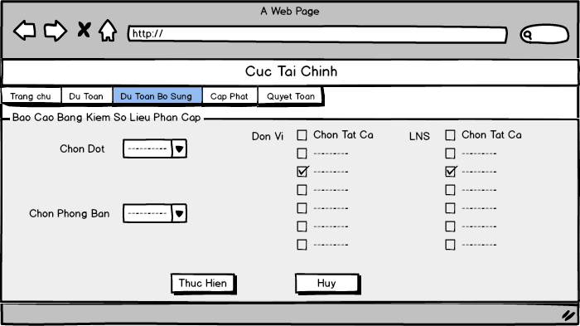

*“Bảng kiểm số liệu phân cấp” report screen*

## Budget Allocation

### 3.3.1 UC034 - Add New Allocation Voucher

|  |  |  |  |
| --- | --- | --- | --- |
| **Use Case ID** | UC034 | **Version** | 1.0 |
| **Use Case Name** | Add new allocation voucher | | |
| **Create By** | VungNV | **Date Created** | 17/10/2015 |
| **Primary Actor** | User | **Secondary Actor** | N/A |
| **Description** | Use can create new allocation voucher to add information of allocation to database | | |
| **Preconditions** | User has already logged in system  User have permission to create new allocation voucher | | |
| **Post conditions** | A new allocation voucher and its details will be created and save in database | | |
| **Normal Flow** | 1. User select [Cấp phát] on the header of home page and click on [Chứng từ cấp phát] hyperlink 2. System redirect to [Chứng từ cấp phát] screen. 3. User click [Tạo mới] button. 4. System redirect to [Thêm mới chứng từ] screen 5. User select type allocation from [Loại cấp phát] dropdown list. 6. User select type income allocation from [Tính chất cấp thu] dropdown list. 7. User select voucher date from [Ngày chứng từ] calander. Default is current date. 8. User input content into [Nội dung] text area. 9. User click [Lưu] button 10. System will be created new voucher 11. System redirects to [Chứng từ chi tiết] screen and display voucher. | | |
| **Alternative Flows** | In step 8: if click [Hủy] button then system redirect to [Chứng từ chi tiết] screen. | | |
| **Exceptions** | N/A | | |
| **Priority** | High | | |
| **Frequency of Use** | High | | |
| **Business Rules** | B9, B12 | | |

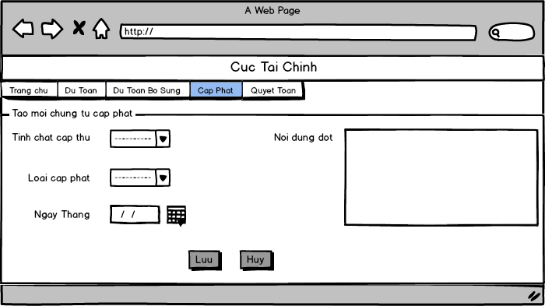

*Add new allocation voucher*

### 3.3.2 UC035 - Update Allocation Voucher

|  |  |  |  |
| --- | --- | --- | --- |
| **Use Case ID** | UC035 | **Version** | 1.0 |
| **Use Case Name** | Update allocation voucher | | |
| **Create By** | VungNV | **Date Created** | 17/10/2015 |
| **Primary Actor** | User | **Secondary Actor** | N/A |
| **Description** | User can update information of voucher when voucher has change | | |
| **Preconditions** | User has already logged in system  User has permission to edit  At least one allocation voucher created before | | |
| **Post conditions** | Allocation voucher will be edited information and save in database | | |
| **Normal Flow** | 1. User click on [Sửa] hyperlink corresponding to voucher in table list. 2. System redirect to [Thêm mới chứng từ] screen 3. User select type allocation from [Loại cấp phát] dropdown list. 4. User select type income allocation from [Tính chất cấp thu] dropdown list. 5. User select voucher date from [Ngày chứng từ] calander. Default is current date. 6. User input content into [Nội dung] text area. 7. User click [Lưu] button 8. System will be updated voucher 9. System redirects to [Chứng từ chi tiết] screen and display voucher. | | |
| **Alternative Flows** | **In step 7:** if click [Hủy] button then system redirect to [Chứng từ chi tiết] screen. | | |
| **Exceptions** |  | | |
| **Priority** | medium | | |
| **Frequency of Use** | Normal | | |
| **Business Rules** | B9, B12 | | |

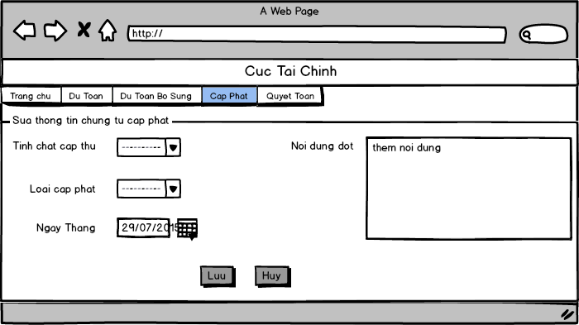

*Update allocation voucher*

### 3.3.3 UC036 - Delete Allocation Voucher

|  |  |  |  |
| --- | --- | --- | --- |
| **Use Case ID** | UC036 | **Version** | 1.0 |
| **Use Case Name** | Delete allocation voucher | | |
| **Create By** | VungNV | **Date Created** | 17/10/2015 |
| **Primary Actor** | User | **Secondary Actor** | N/A |
| **Description** | User can delete an allocation voucher | | |
| **Preconditions** | User has already logged in system  User has permission to delete  At least one allocation voucher created before | | |
| **Post conditions** | Allocation voucher will be deleted and removed in list table | | |
| **Normal Flow** | 1. User select [Cấp phát] on the header of home page click [Chứng từ cấp phát] hyperlink 2. System redirect to [Chứng từ cấp phát] screen, allocation voucher is listed in [Danh sách cấp phát] table 3. User click [Xóa] button of allocation voucher that want to delete 4. System will display popup to confirm    * + Click [Ok] button to delete allocation voucher and then allocation voucher will be removed from [Danh sách đợt dự toán] table      + Click [Cancel] to cancel requestion. 5. Popup will be closed | | |
| **Alternative Flows** | N/A | | |
| **Exceptions** | N/A | | |
| **Priority** | High | | |
| **Frequency of Use** | Normal | | |
| **Business Rules** | N/A | | |

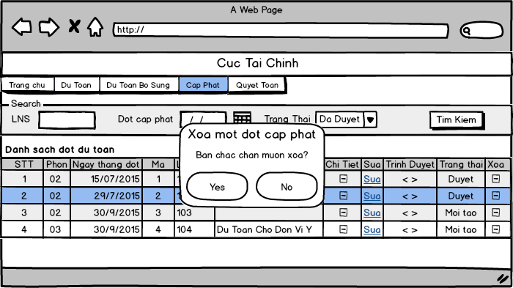

*Delete allocation voucher*

### 3.3.4 UC037 - View Allocation Voucher

|  |  |  |  |
| --- | --- | --- | --- |
| **Use Case ID** | UC037 | **Version** | 1.0 |
| **Use Case Name** | View allocation voucher | | |
| **Create By** | VungNV | **Date Created** | 17/10/2015 |
| **Primary Actor** | User | **Secondary Actor** | N/A |
| **Description** | User can view list of all allocation voucher | | |
| **Preconditions** | User has already logged in system  User has permission to view | | |
| **Post conditions** | Display list of existed voucher | | |
| **Normal Flow** | 1. User select [Cấp phát] on the header of home page and click [Chứng từ cấp phát] hyperlink 2. System redirect to [Chứng từ cấp phát] screen, Allocation Voucher is listed in [Danh sách đợt cấp phát] table | | |
| **Alternative Flows** | **N/A** | | |
| **Exceptions** | **N/A** | | |
| **Priority** | High | | |
| **Frequency of Use** | High | | |
| **Business Rules** | N/A | | |

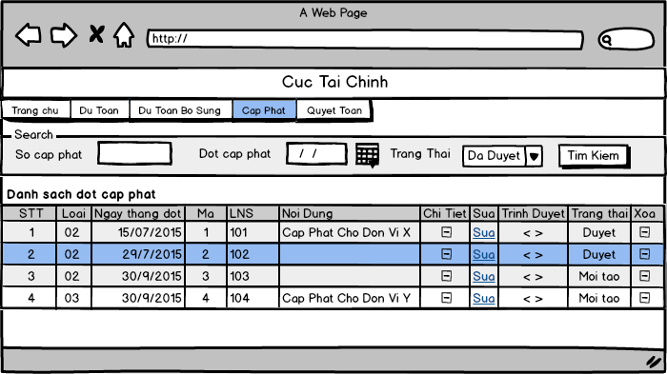

*View allocation voucher*

### 3.3.5 UC038 - Search Allocation Voucher

|  |  |  |  |
| --- | --- | --- | --- |
| **Use Case ID** | UC038 | **Version** | 1.0 |
| **Use Case Name** | Search allocation voucher | | |
| **Create By** | VungNV | **Date Created** | 17/10/2015 |
| **Primary Actor** | User | **Secondary Actor** | N/A |
| **Description** | User can search voucher with one or more condition: budget type, date time, status | | |
| **Preconditions** | User has already logged in system | | |
| **Post conditions** | Display list of vouchers which user want to view | | |
| **Normal Flow** | 1. User select [Cấp phát] on the header of home page and click [Chứng từ cấp phát] hyperlink 2. System redirect to [Chứng từ cấp phát] screen 3. User select one or more condition to search    * + Enter number to [Số chứng từ] textbox to search by voucher number      + Select Allocation kind from [Loại cấp phát] drop-down list to search by kind      + Select status from [Trạng thái] drop-down list to search by status      + Select date from [Từ ngày] datebox to search all voucher added after date selected      + Select date from [Đến ngày] datebox to search all voucher added before date selected 4. User click on [Tìm kiếm] button to search 5. System displays result in [Danh sách cấp phát] table | | |
| **Alternative Flows** | N/A | | |
| **Exceptions** | N/A | | |
| **Priority** | High | | |
| **Frequency of Use** | High | | |
| **Business Rules** | B6 | | |



*Search allocation voucher*

### 3.3.6 UC039 - Update Allocation Voucher Detail

|  |  |  |  |
| --- | --- | --- | --- |
| **Use Case ID** | UC039 | **Version** | 1.0 |
| **Use Case Name** | Update allocation voucher detail | | |
| **Create By** | VungNV | **Date Created** | 17/10/2015 |
| **Primary Actor** | User | **Secondary Actor** | N/A |
| **Description** | User can update allocation voucher’s detail | | |
| **Preconditions** | User has already logged in system  User has permission to edit detail | | |
| **Post conditions** | Allocation voucher’s detail will be updated and save in database | | |
| **Normal Flow** | 1. User select [Cấp phát] on the header of home page and click [Chứng từ cấp phát] hyperlink 2. System redirect to [Chứng từ cấp phát] screen, allocation voucher is listed in [Danh sách cấp phát] table 3. User click [Số cấp phát] hyperlink of allocation voucher that want to update 4. System redirect to [Sửa thông tin chứng từ] screen 5. User enters information of allocation voucher detail 6. System checks for keyword validation. It deletes all those invalid keyword after user enters it. 7. User click [Thực hiện] button to update voucher of allocation then redirect to [Cấp phát chứng từ] screen. | | |
| **Alternative Flows** | **In step 7,**  Click [Quay lại] button to cancel update allocation voucher and then system go back [Cấp phát chứng từ] screen | | |
| **Exceptions** | N/A | | |
| **Priority** | High | | |
| **Frequency of Use** | High | | |
| **Business Rules** | B5 | | |

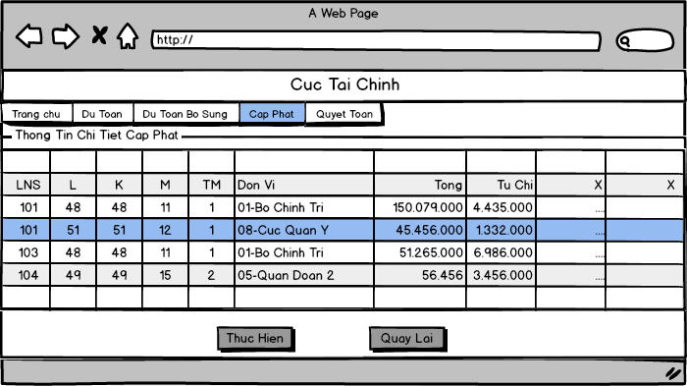

*Update allocation voucher detail*

### 3.3.7 UC040 - View Allocation Voucher Detail

|  |  |  |  |
| --- | --- | --- | --- |
| **Use Case ID** | UC040 | **Version** | 1.0 |
| **Use Case Name** | View allocation voucher detail | | |
| **Create By** | VungNV | **Date Created** | 17/10/2015 |
| **Primary Actor** | User | **Secondary Actor** | N/A |
| **Description** | User views the detail information of the Allocation Voucher. | | |
| **Preconditions** | User is in [Danh sách chứng từ] screen ,performed the “Search Allocation Voucher “ function and screen is displaying the Allocation Voucher list | | |
| **Post conditions** | The chosen Allocation Voucher detail screen is displayed | | |
| **Normal Flow** | 1. User click on [Số chứng từ] hyperlink in one of Allocation Voucher list’s elements 2. System redirects to [Chứng từ chi tiết] screen and display all detail information of Allocation Voucher in this screen grid’s form | | |
| **Alternative Flows** | N/A | | |
| **Exceptions** | N/A | | |
| **Priority** | High | | |
| **Frequency of Use** | High | | |
| **Business Rules** | N/A | | |



*View allocation voucher detail*

### 3.3.8 UC041 - Filter Allocation Voucher Detail

|  |  |  |  |
| --- | --- | --- | --- |
| **Use Case ID** | UC041 | **Version** | 1.0 |
| **Use Case Name** | Filter allocation voucher detail | | |
| **Create By** | VungNV | **Date Created** | 17/10/2015 |
| **Primary Actor** | User | **Secondary Actor** | N/A |
| **Description** | User can filter detail information of voucher by budget type, section, subsection… | | |
| **Preconditions** | User has already logged in system  At least one voucher has detail information created before | | |
| **Post conditions** | The filtering result is displayed to view | | |
| **Normal Flow** | 1. User select [Cấp phát] on the header of home page and click [Chứng từ cấp phát] hyperlink 2. System redirect to [Chứng từ cấp phát] screen, allocation voucher is listed in [Danh sách chứng từ] table 3. User click [Chi Tiết] button to view allocation voucher detail 4. System redirect to [Thông tin chứng từ] screen 5. User enters budget type or section ,subsection… to be filtered 6. System reloads the allocation voucher detail grid and display the filtered information | | |
| **Alternative Flows** | N/A | | |
| **Exceptions** | N/A | | |
| **Priority** | High | | |
| **Frequency of Use** | High | | |
| **Business Rules** | N/A | | |

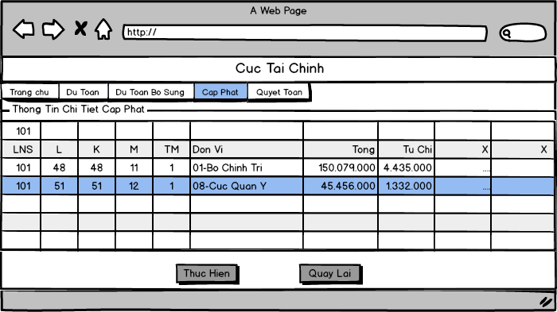

*Filter allocation voucher detail*

### 3.3.9 UC042 - Approve Allocation Voucher

|  |  |  |  |
| --- | --- | --- | --- |
| **Use Case ID** | UC042 | **Version** | 1.0 |
| **Use Case Name** | Approve allocation voucher | | |
| **Create By** | VungNV | **Date Created** | 17/10/2015 |
| **Primary Actor** | User | **Secondary Actor** | N/A |
| **Description** | User can approve a allocation voucher | | |
| **Preconditions** | User has already logged in system  User has permission approve  At least one voucher created before | | |
| **Post conditions** | Allocation voucher will be approved and changed status of voucher | | |
| **Normal Flow** | 1. User select [Cấp phát] on the header of home page and click [Chứng từ cấp phát] hyperlink 2. System redirect to [Chứng từ cấp phát] screen, allocation voucher is listed in [Danh sách cấp phát] table 3. User click [Số cấp phát] hyperlink of allocation voucher that want to update 4. System redirect to [Thông tin chứng từ] screen 5. User click [Trình duyệt] button 6. System will display popup [Duyệt chứng từ] to confirm 7. User input reason in [Lý do] text area 8. User click [Tiếp tục] button to approve allocation voucher 9. Popup will be closed   9. Allocation voucher will be changed status on [Danh sách cấp phát] table | | |
| **Alternative Flows** | **After step 8 ,**  If Click [Hủy] to cancel approve then popup will be closed  And allocation voucher does not change status | | |
| **Exceptions** | N/A | | |
| **Priority** | High | | |
| **Frequency of Use** | High | | |
| **Business Rules** | N/A | | |

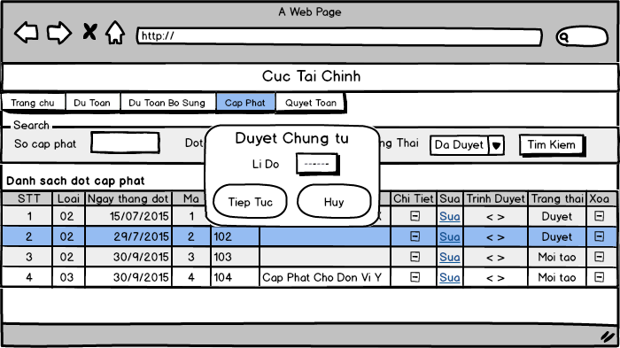

*Approve allocation voucher*

### 3.3.10 UC043 - Export “*Cấp Phát Thông Tri*” Report

|  |  |  |  |
| --- | --- | --- | --- |
| **Use Case ID** | UC043 | **Version** | 1.0 |
| **Use Case Name** | Export “*Cấp Phát Thông Tri*” reports | | |
| **Create By** | **HungPH** | **Date Create** | **17/10/2015** |
| **Primary Actor** | **User** | **Secondary Actor** | **N/A** |
| **Description** | User export a report name “*Cấp Phát Thông Tri*” after choose condition for report’s information | | |
| **Preconditions** | User has already logged in System  User has permission to export report  Have Allocation’s data in database from vouchers | | |
| **Post conditions** | “*Cấp Phát Thông Tri*” reports is exported and display in another browse tab | | |
| **Normal Flow** | 1. User click on [Danh Sách Báo Cáo] hyperlink on [Cấp Phát] Menu Tab 2. System redirect to [Danh Sách Báo Cáo] screen 3. User click on [Cấp Phát Thông Tri] hyperlink on screen 4. System redirect to [Cấp Phát Thông Tri] report screen 5. User select all condition to export report  * Select Phase from [Chọn Đợt] drop-down list * Select Allocation type from [Loại cấp phát] text box * Select Allocation budget type from [Loại NS Cấp Phát] drop-down list * Select Division from [Chọn phòng ban] drop-down list * Select one or more budget kind from [Chọn LNS] check list which display base on all condition selected before * Select one or more Unit from [Chọn đơn vị] check list which display base on budget kind selected before * Select [Chi Tiet DV] or [Tong Hop DV] to export general report or export report for each Unit * Select [Đến Ngành] or [Đến Mục] to choose detail level for report * User can take note in [Ghi chú] text field  1. User click [Thực Hiện] button to create report 2. Report created (pdf file) | | |
| **Alternative Flows** | **User not select Phase:**  [Chọn LNS] check list not display  **User not select Allocation type:**  [Chọn LNS] check list not display  **User not select settlement budget type:**  [Chọn LNS] check list not display  **In step 6 user click on [Hủy] button**  System will redirect to [Danh Sách Báo Cáo] screen  **In any step after step 4, user click on [Trang chủ] hyperlink**  System will redirect to Home screen | | |
| **Exceptions** | **E1**-**User no select [Đơn vị]**  A message “*Chưa chọn điều kiện đơn vị*”  **E1**-**User no select [LNS]**  A message “*Chưa chọn điều kiện LNS*” | | |
| **Priority** | High | | |
| **Frequency of Use** | High | | |
| **Business Rules** | B2, B10 | | |

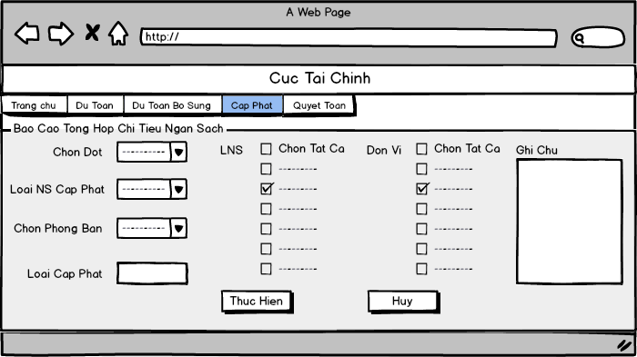

*“Cấp Phát Thông Tri” report screen*

## Budget Settlement

### 3.4.1 UC044 - Add New Settlement Voucher

|  |  |  |  |
| --- | --- | --- | --- |
| **Use Case ID** | UC044 | **Version** | 1.0 |
| **Use Case Name** | Add new settlement voucher | | |
| **Create By** | HungPH | **Date Create** | 17/10/2015 |
| **Primary Actor** | User | **Secondary Actor** | N/A |
| **Description** | Use can create new settlement voucher to add information of settlement to database | | |
| **Preconditions** | User has already logged in system  User have permission to create new settlement voucher | | |
| **Post conditions** | A new settlement voucher and its details will be created and save in database | | |
| **Normal Flow** | 1. User select [Quyết Toán] on the header of home page and click on [Danh sách chứng từ] hyperlink 2. System redirect to [Chứng từ quyết toán] screen 3. User click on [Tạo mới] button 4. System will redirect to [Thêm Mới Chứng Từ] screen include settlement voucher’s information field to enter 5. User select Unit from [Đơn Vị] drop-down list 6. User select Budget from [Loại Ngân Sách] drop-down list (default is 1st kind of Budget) 7. User select Quarter from [Quý] drop-down list (default is 1st quarter) 8. User select Date from [Ngày chứng từ] calendar (default is current date) 9. User enter detail in [Nội dung] text field 10. User click on [Lưu] button to save new settlement voucher 11. System will redirect to [Thông tin chứng từ] screen to enter information of settlement voucher 12. User click on [Thực hiện] button 13. System will redirect to [Danh Sách Chứng Từ] screen. | | |
| **Alternative Flows** | **In any step after step 4, user click [Hủy] button**  System redirect to [Danh Sách Chứng Từ] screen. | | |
| **Exceptions** | **E1-No select Unit (step 5)**   1. System indicates that the unit not entered 2. A message “Bạn chưa chọn đơn vị!” | | |
| **Priority** | High | | |
| **Frequency of Use** | High | | |
| **Business Rules** | B2, B9 | | |

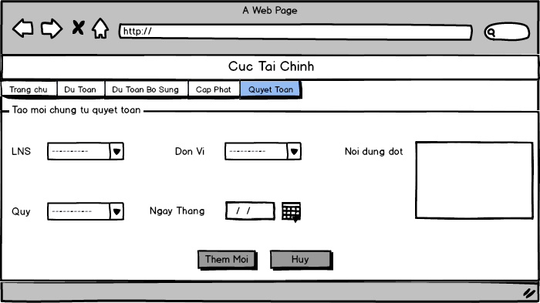

*Add new settlement voucher*

### 3.4.2 UC045 - Update Settlement Voucher

|  |  |  |  |
| --- | --- | --- | --- |
| **Use Case ID** | UC045 | **Version** | 1.0 |
| **Use Case Name** | Update settlement voucher | | |
| **Create By** | HungPX | **Date Created** | 17/10/2015 |
| **Primary Actor** | User | **Secondary Actor** | N/A |
| **Description** | User can update information of voucher when voucher has change | | |
| **Preconditions** | User has already logged in system  User has permission to edit  At least one settlement voucher created before | | |
| **Post conditions** | Settlement voucher will be edited information and save in database | | |
| **Normal Flow** | 1. User select [Quyết Toán] on the header of home page click on [Danh sách chứng từ] hyperlink 2. System redirect to [Chứng từ quyết toán] screen, estimation voucher is listed in [Danh sách Quyết Toán] table 3. User click on [Sửa] hyperlink in one of settlement voucher list elements 4. System redirect to settlement voucher edit page which includes all information fields to be edited. 5. User enters all information needed to edit and clicks “Lưu” button 6. System saves new information of settlement voucher to database and redirects to [Danh sách chứng từ] page which remains all previous search conditions and display settlement list. | | |
| **Alternative Flows** | **In step 6. User clicks on [Hủy] button instead of [Lưu] button**   1. User click on [Hủy] button 2. System redirects to [Danh sách chứng từ] page which remains all previous search condition and display settlement list without saving information of settlement voucher to database | | |
| **Exceptions** | **E1 – Invalid Unit**   * System indicates that user hasn’t chosen any unit * A message is displayed *“Bạn chưa chọn đơn vị!”* | | |
| **Priority** | High | | |
| **Frequency of Use** | Normal | | |
| **Business Rules** | B2, B9 | | |

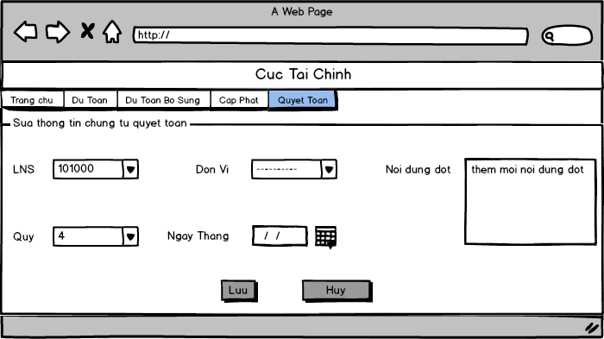

*Update settlement voucher*

### 3.4.3 UC046 - Delete Settlement Voucher

|  |  |  |  |
| --- | --- | --- | --- |
| **Use Case ID** | UC046 | **Version** | 1.0 |
| **Use Case Name** | Delete settlement voucher | | |
| **Create By** | HungPX | **Date Created** | 17/10/2015 |
| **Primary Actor** | User | **Secondary Actor** | N/A |
| **Description** | User can delete an settlement voucher | | |
| **Preconditions** | User has already logged in system  User has permission to delete  At least one settlement voucher created before | | |
| **Post conditions** | The chosen settlement voucher is deleted and removed in list table | | |
| **Normal Flow** | 1. User select [Quyết Toán] on the header of home page and click on [Danh sách chứng từ] hyperlink 2. System redirect to [Chứng từ quyết toán] screen, estimation voucher is listed in [Danh sách Quyết Toán] table 3. User click on [Xóa] hyperlink in one of settlement voucher list’s elements 4. System display a confirm message*: “Bạn có chắc chắn muốn xóa không”*. 5. User clicks [OK] button 6. System performs settlement voucher delete action and updates the database. After that it redirects to [Danh sách chứng từ] page which remains all previous search condition and display settlement list. | | |
| **Alternative Flows** | **In step 5. User clicks on [Cancel] button instead of [OK] button**   1. User click on [Cancel]button 2. System redirects to [Danh sách chứng từ] page which remains all previous search result without deleting the settlement voucher | | |
| **Exceptions** | **N/A** | | |
| **Priority** | High | | |
| **Frequency of Use** | Normal | | |
| **Business Rules** | N/A | | |

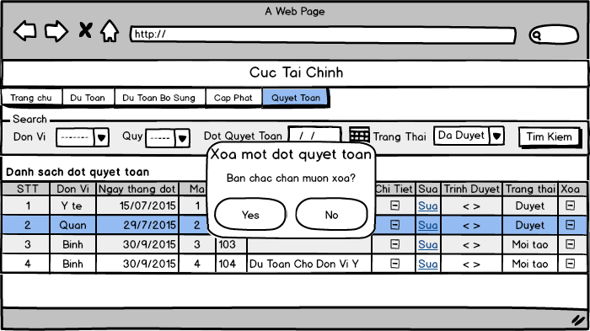

*Delete settlement voucher*

### 3.4.4 UC047 - View List Settlement Voucher

|  |  |  |  |
| --- | --- | --- | --- |
| **Use Case ID** | UC047 | **Version** | 1.0 |
| **Use Case Name** | View list Settlement voucher | | |
| **Create By** | HungPH | **Date Created** | 17/10/2015 |
| **Primary Actor** | User | **Secondary Actor** | N/A |
| **Description** | User can view list of all settlement voucher | | |
| **Preconditions** | User has already logged in system  User has permission to view | | |
| **Post conditions** | Display list of settlement voucher in the table | | |
| **Normal Flow** | 1. User select [Quyết Toán] on header of home page and click on [Danh Sách Chứng Từ] hyperlink 2. System redirect to [Quyết Toán Chứng Từ] screen, settlement voucher is listed in [Danh sách quyết toán] table | | |
| **Alternative Flows** | N/A | | |
| **Exceptions** | N/A | | |
| **Priority** | High | | |
| **Frequency of Use** | High | | |
| **Business Rules** | N/A | | |

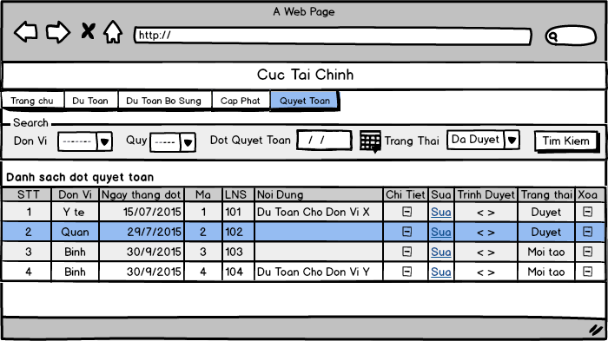

*View list Settlement voucher*

### 3.4.5 UC048 - Search Settlement Voucher

|  |  |  |  |
| --- | --- | --- | --- |
| **Use Case ID** | UC048 | **Version** | 1.0 |
| **Use Case Name** | Search settlement voucher | | |
| **Create By** | HungPH | **Date Created** | 17/10/2015 |
| **Primary Actor** | User | **Secondary Actor** | N/A |
| **Description** | User can search voucher with one or more condition: budget type, date time, status | | |
| **Preconditions** | User has already logged in system | | |
| **Post conditions** | Display list of vouchers which user want to view | | |
| **Normal Flow** | 1. User select [Quyết Toán] on the header of home page and click on [Danh Sách Chứng Từ] hyperlink 2. System will redirect to [Quyết Toán Chứng từ] screen have search panel 3. User select one or more condition to search  * Select Unit from [Đơn vị] drop-down list to search by Unit’s name * Select Quarter from [Quý] drop-down list to search by Quarter * Enter number to [Số chứng từ] textbox to search by voucher number * Select date from [Ngày chứng từ từ ngày] datebox to search all voucher added after date selected * Select date from [Đến ngày] datebox to search all voucher added before date selected * Select status from [Trạng thái] drop-down list to search by status  1. User click on [Tìm kiếm] button to search 2. System displays result | | |
| **Alternative Flows** | N/A | | |
| **Exceptions** | N/A | | |
| **Priority** | High | | |
| **Frequency of Use** | High | | |
| **Business Rules** | B6 | | |



*Search settlement voucher*

### 3.4.6 UC049 - Update Settlement Voucher Detail

|  |  |  |  |
| --- | --- | --- | --- |
| **Use Case ID** | UC049 | **Version** | 1.0 |
| **Use Case Name** | Update settlement voucher detail | | |
| **Create By** | HungPX | **Date Created** | 17/10/2015 |
| **Primary Actor** | User | **Secondary Actor** | N/A |
| **Description** | User can update settlement voucher’s detail | | |
| **Preconditions** | User has already logged in system  User has permission to edit detail | | |
| **Post conditions** | Settlement voucher’s detail will be updated and save in database | | |
| **Normal Flow** | 1. User select [Quyết Toán] on the header of home page and click [Danh Sách Chứng Từ] hyperlink 2. System redirect to [Quyết Toán Chứng Từ] screen, estimation voucher is listed in [Danh sách quyết toán] table 3. User click [Chi Tiết] button to view estimation voucher detail 4. System redirect to [Quyết Toán Chứng Từ Chi Tiết] screen 5. User enters information of settlement voucher detail 6. System checks for keyword validation. It deletes all those invalid keyword after user enters it. 7. User clicks [Thực hiện] button or presses hotkey [F10] 8. System saves information in settlement voucher detail to database. The displaying page [Chứng từ chi tiết] is not be redirected. | | |
| **Alternative Flows** | **In step 6.** User clicks on [Quay lại] button instead of [Thực hiện] button or press hotkey [F10]   1. User click on [Quay lại] button 2. System redirects to “Danh sách chứng từ” page which remains all previous search result without saving settlement voucher detail to database | | |
| **Exceptions** | N/A | | |
| **Priority** | High | | |
| **Frequency of Use** | High | | |
| **Business Rules** | B5 | | |

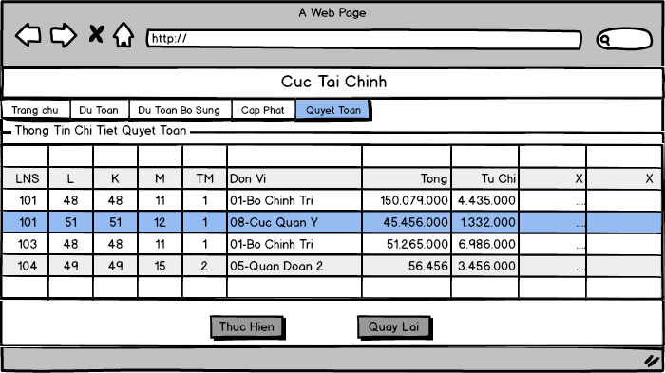

*Update settlement voucher detail*

### 3.4.7 UC050 - View Settlement Voucher Detail

|  |  |  |  |
| --- | --- | --- | --- |
| **Use Case ID** | UC050 | **Version** | 1.0 |
| **Use Case Name** | View settlement voucher detail | | |
| **Create By** | HungPX | **Date Created** | 17/10/2015 |
| **Primary Actor** | User | **Secondary Actor** | N/A |
| **Description** | User views the detail information of the settlement Voucher. | | |
| **Preconditions** | User is in [Danh sách chứng từ] screen, performed the “*Search settlement voucher*” function and screen is displaying the settlement voucher list | | |
| **Post conditions** | The chosen settlement voucher detail screen is displayed | | |
| **Normal Flow** | 1. User select [Quyết Toán] on the header of home page and click [Danh sách chứng từ] hyperlink 2. System redirect to [Quyết Toán Chứng Từ] screen 3. User click on [Số chứng từ] hyperlink in one of settlement voucher list’s elements 4. System redirects to [Chứng từ chi tiết] screen and display all detail information of settlement voucher in this screen grid’s form | | |
| **Alternative Flows** | N/A | | |
| **Exceptions** | N/A | | |
| **Priority** | High | | |
| **Frequency of Use** | High | | |
| **Business Rules** | N/A | | |



*View settlement voucher detail*

### 3.4.8 UC051 - Filter Settlement Voucher Detail

|  |  |  |  |
| --- | --- | --- | --- |
| **Use Case ID** | UC051 | **Version** | 1.0 |
| **Use Case Name** | Filter settlement voucher detail | | |
| **Create By** | HungPX | **Date Created** | 17/10/2015 |
| **Primary Actor** | User | **Secondary Actor** | N/A |
| **Description** | User can filter detail information of voucher by budget type, section, subsection… | | |
| **Preconditions** | User has already logged in system  At least one voucher has detail information created before | | |
| **Post conditions** | The filtering result is displayed to view | | |
| **Normal Flow** | 1. User select [Quyết Toán] on the header of home page and click [Danh sách chứng từ] hyperlink 2. System redirect to [Quyết Toán Chứng Từ] screen, estimation voucher is listed in [Danh sách quyết toán] table 3. User click [Chi Tiết] button to view estimation voucher detail 4. System redirect to [Quyết Toán Chứng Từ Chi Tiết] screen 5. User enters budget type to be filtered 6. System reloads the settlement voucher detail grid and display the filtered information | | |
| **Alternative Flows** | N/A | | |
| **Exceptions** | N/A | | |
| **Priority** | High | | |
| **Frequency of Use** | High | | |
| **Business Rules** | N/A | | |

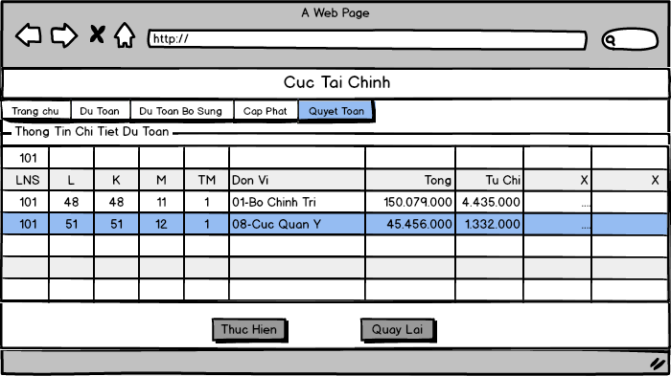

*Filter settlement voucher detail*

### 3.4.9 UC052 - Export “*Báo cáo quyết toán LNS Đơn vị*” Report

|  |  |  |  |
| --- | --- | --- | --- |
| **Use Case ID** | UC052 | **Version** | 1.0 |
| **Use Case Name** | Export “*Báo cáo quyết toán LNS Đơn vị*” Report | | |
| **Create By** | HungPX | **Date Created** | 17/10/2015 |
| **Primary Actor** | User | **Secondary Actor** | N/A |
| **Description** | User select condition to export “Báo cáo quyết toán LNS Đơn vị” report with information they want | | |
| **Preconditions** | User is in [Báo cáo quyết toán LNS Đơn vị] screen  Have settlement’s data in database from vouchers | | |
| **Post conditions** | Budget allocation target comparison report is created | | |
| **Normal Flow** | 1. User selects quarter in [Quý] combobox, year in [Năm] combo box ,department in [Phòng Ban] combo box and budget type in[Loại ngân sách] list of check box 2. By using these selection, System gets and reload [đơn vị] list of check box 3. User selects unit in [đơn vị] list of check box 4. User clicks [Thực hiện] button 5. System displays report result in another tab page | | |
| **Alternative Flows** | **In step 4.** User clicks on [Hủy] button instead of [Thực hiện] button   1. User click on [Hủy] button 2. System redirects to [Danh sách báo cáo] page | | |
| **Exceptions** | N/A | | |
| **Priority** | High | | |
| **Frequency of Use** | High | | |
| **Business Rules** | B2, B10 | | |

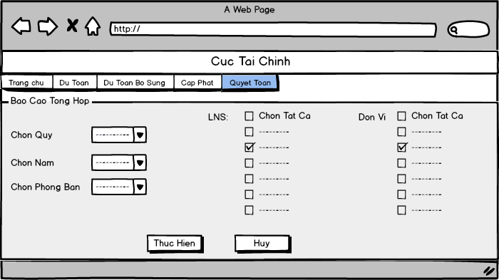

*Export “Báo cáo quyết toán LNS Đơn vị” Report*

### UC053 - Export “*Quyết Toán Tổng Hợp*” Report

|  |  |  |  |
| --- | --- | --- | --- |
| **Use Case ID** | UC053 | **Version** |  |
| **Use Case Name** | Export “*Quyết Toán Tổng Hợp*” report | | |
| **Create By** | HungPH | **Date Created** | 20/10/2015 |
| **Primary Actor** | User | **Secondary Actor** | N/A |
| **Description** | User select condition to export “*Quyết Toán Tổng Hợp*” report with information they want | | |
| **Preconditions** | User has already logged in System  User has permission to export report  Have settlement’s data in database from vouchers | | |
| **Post conditions** | The report which they want to view had created | | |
| **Normal Flow** | 1. User select [Quyết Toán] on the header of home page and click [Danh sách báo cáo] hyperlink 2. System redirect to [Danh sách báo cáo] screen 3. User click [Quyết toán Tổng hợp] hyperlink to redirect to [Quyết toán Tổng hợp] report screen 4. User select all condition to export report  * Select Quarter from [Chọn Quý] drop-down list * Select Year from [Chọn Năm] drop-down list * Select Division from [Chọn phòng ban] drop-down list  1. User select one or more budget kind from [Loại Ngân Sách] check list which display base on all condition selected before (Quarter, Year, Division) 2. User select one or more Unit from [Chọn đơn vị] check list which display base on all condition selected before (Quarter, Year, Division, budget kind) 3. User click [Thực Hiện] button to create report 4. Report had created and show in new browsers tab | | |
| **Alternative Flows** | **In step 7, user click [Hủy] button**  System redirect to [Danh sách báo cáo] screen | | |
| **Exceptions** | **E1 – No select budget kind**  A message “*Chưa chọn loại ngân sách”*  **E2 – No select Unit**  A message “*Chưa chọn đơn vị*” | | |
| **Priority** | High | | |
| **Frequency of Use** | High | | |
| **Business Rules** | B2, B10 | | |



*Export “Quyết Toán Tổng Hợp” report*

### UC054 - Export “*Quyết toán Tổng hợp nhập số liệu*” Report

|  |  |  |  |
| --- | --- | --- | --- |
| **Use Case ID** | UC054 | **Version** | 1.0 |
| **Use Case Name** | Export “*Quyết toán Tổng hợp nhập số liệu*” report | | |
| **Create By** | HungPH | **Date Created** | 20/10/2015 |
| **Primary Actor** | User | **Secondary Actor** |  |
| **Description** | User select condition to export “*Quyết Toán Tổng Hợp số liệu nhập*” report with information they want | | |
| **Preconditions** | User has already logged in System  User has permission to export report  Have settlement’s data in database from vouchers | | |
| **Post conditions** | The report which they want to view had created | | |
| **Normal Flow** | 1. User select [Quyết Toán] on the header of home page and click [Danh sách báo cáo] hyperlink 2. System redirect to [Danh sách báo cáo] screen 3. User click [Quyết toán Tổng hợp Nhập số liệu] hyperlink 4. System redirect to [Quyết toán Tổng hợp Nhập số liệu] report screen 5. User select all condition to export report  * Select Quarter from [Chọn Quý] drop-down list * Select Year from [Chọn Năm] drop-down list * Select Division from [Chọn phòng ban] drop-down list  1. User click [Thực Hiện] button to create report 2. Report had created and show in new browsers tab | | |
| **Alternative Flows** | **In step 5, user click [Hủy] button**  System redirect to [Danh sách báo cáo] screen | | |
| **Exceptions** | N/A | | |
| **Priority** | High | | |
| **Frequency of Use** | High | | |
| **Business Rules** | N/A | | |

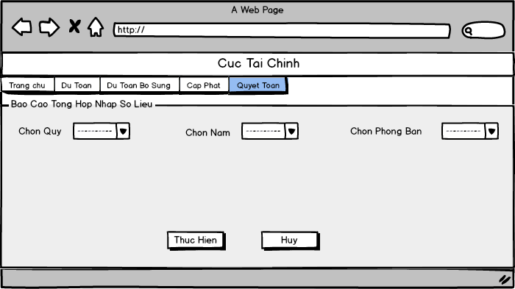

*Export “Quyết toán Tổng hợp nhập số liệu” report*

### UC055 - Export “*Quyết Toán Thông Tri*” Reports

|  |  |  |  |
| --- | --- | --- | --- |
| **Use Case ID** | UC055 | **Version** | 1.0 |
| **UCID and Name** | Export “*Quyết Toán Thông Tri*” reports | | |
| **Create By** | **HungPH** | **Date Create** | **17/10/2015** |
| **Primary Actor** | **User** | **Secondary Actor** | **N/A** |
| **Description** | User export “*Quyết Toán Thông Tri*” report | | |
| **Preconditions** | User has already logged in system  User has permission to export report  Have settlement’s data in database from vouchers | | |
| **Post conditions** | User can view report which they want to view | | |
| **Normal Flow** | 1. User click on [Danh Sách Báo Cáo] hyperlink on [Quyết Toán] Menu Tab 2. System redirect to [Danh Sách Báo Cáo] screen 3. User click on [Quyết Toán Thông Tri] hyperlink on screen 4. System redirect to [Quyết Toán Thông Tri] report screen 5. User select all condition to export report  * Select Quarter from [Chọn Quý] drop-down list * Select Year from [Chọn Năm] drop-down list * Select settlement budget type from [Loại NS Quyết toán] drop-down list * Select Division from [Chọn phòng ban] drop-down list * Select one or more budget kind from [Chọn LNS] check list which display base on all condition selected before * Select one or more Unit from [Chọn đơn vị] check list which display base on budget kind selected before * Select [Chi Tiet DV] or [Tong Hop DV] to export general report or export report for each Unit * Select [Đến Ngành] or [Đến Mục] to choose detail level for report * User can take note in [Ghi chú] text field  1. User click [Thực Hiện] button to create report 2. Report created (pdf file) | | |
| **Alternative Flows** | **User not select Quarter:**  [Chọn LNS] check list not display  **User not select Year:**  [Chọn LNS] check list not display  **User not select settlement budget type:**  [Chọn LNS] check list not display  **In step 6 user click on [Hủy] button**  System will redirect to [Danh Sách Báo Cáo] screen  **In any step after step 4, user click on [Trang chủ] hyperlink**  System will redirect to Home screen | | |
| **Exceptions** | **E1**-**User no select [Đơn vị]**  A message “*Chưa chọn điều kiện đơn vị*”  **E1**-**User no select [LNS]**  A message “*Chưa chọn điều kiện LNS*” | | |
| **Priority** | High | | |
| **Frequency of Use** | High | | |
| **Business Rules** | B2, B10 | | |

### UC056 - Export “*Quyết toán chọn Đơn vị - LNS*” Report

|  |  |  |  |
| --- | --- | --- | --- |
| **Use Case ID** | UC056 | **Version** |  |
| **Use Case Name** | Export “*Quyết toán chọn Đơn vị - LNS*” report | | |
| **Create By** | HungPX | **Date Created** | 20/10/2015 |
| **Primary Actor** | User | **Secondary Actor** | N/A |
| **Description** | Exporting the settlement report which include information of all selected budget type of each unit | | |
| **Preconditions** | User has already logged in System  User has permission to export report  Have settlement’s data in database from vouchers | | |
| **Post conditions** | “*Quyết toán chọn DonVi_LNS*” report is exported | | |
| **Normal Flow** | 1. User selects [Quyết Toán] on the header of home page and click [Danh sách báo cáo] hyperlink 2. System redirect to [Danh sách báo cáo ngân sách quốc phòng] screen 3. User clicks on [Quyết toán chọn Đơn vị - LNS] hyperlink 4. System redirects to [Quyết toán chọn Đơn vị - LNS] screen 5. User select all condition to export report  * Select the quarter in [Quý] dropdown list * Select budgetary year in [Năm] dropdown list * Select department in [Phòng ban] dropdown list * Select Unit in [Đơn vị] list.  1. System shows the budget type in [Loại ngân sách] list of check box depend on the selected user options. 2. User selects budget type in [Loại ngân sách] list of check box and then clicks the [Thực hiện] button. 3. System exports the report in new page | | |
| **Alternative Flows** | **In step 7. User clicks on [Hủy] button instead of [Thực hiện] button**   1. User clicks on [Hủy] button 2. System redirects to [Danh sách báo cáo ngân sách quốc phòng] screen | | |
| **Exceptions** | **N/A** | | |
| **Priority** | High | | |
| **Frequency of Use** | High | | |
| **Business Rules** | B2, B10 | | |

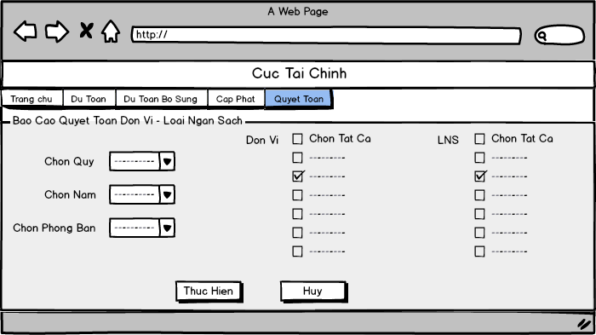

*“Quyết toán chọn Đơn vị - LNS” report*

### UC057 - Export “*Quyết toán tổng hợp chọn LNS*” Report

|  |  |  |  |
| --- | --- | --- | --- |
| **Use Case ID** | UC057 | **Version** |  |
| **Use Case Name** | Export “*Quyết toán tổng hợp chọn LNS*” report | | |
| **Create By** | HungPX | **Date Created** | 20/10/2015 |
| **Primary Actor** | User | **Secondary Actor** | N/A |
| **Description** | Exporting the settlement report which include information of all selected budget type of all unit | | |
| **Preconditions** | User has already logged in System  User has permission to export report  Have settlement’s data in database from vouchers | | |
| **Post conditions** | “*Quyết toán tổng hợp chọn LNS*” report is exported | | |
| **Normal Flow** | 1. User selects [Quyết Toán] on the header of home page and click [Danh sách báo cáo] hyperlink 2. System redirect to [Danh sách báo cáo ngân sách quốc phòng] screen 3. User clicks on [Quyết toán tổng hợp chọn LNS] hyperlink 4. System redirects to [Quyết toán tổng hợp chọn LNS] screen 5. User selects all conditions to export report  * Select the quarter in [Quý] dropdown list * Select budgetary year in [Năm] dropdown list * Select department in [Phòng ban] dropdown list * Select Budget type in [Loại ngân sách] list.  1. System shows the sheet in [Tờ] list of check box depend on the selected user options. 2. User selects sheet in [Tờ] list of check box and then clicks the [Thực hiện] button. 3. System exports the report(s) in new page(s) | | |
| **Alternative Flows** | **In step 7. User clicks on [Hủy] button instead of [Thực hiện] button**   1. User clicks on [Hủy] button 2. System redirects to [Danh sách báo cáo ngân sách quốc phòng] screen | | |
| **Exceptions** | **N/A** | | |
| **Priority** | High | | |
| **Frequency of Use** | High | | |
| **Business Rules** | B2, B13 | | |

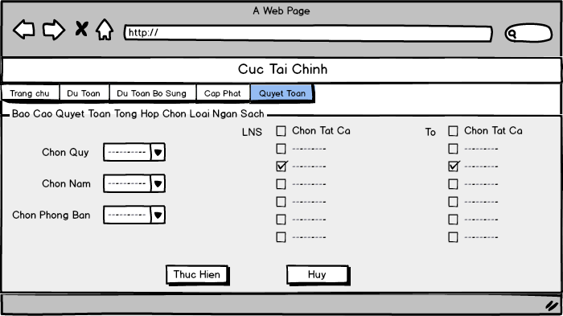

*“Quyết toán tổng hợp chọn LNS” report*

### UC058 - Export “*Quyết toán tổng hợp năm-quý*” Report

|  |  |  |  |
| --- | --- | --- | --- |
| **Use Case ID** | UC058 | **Version** |  |
| **Use Case Name** | Export “*Quyết toán tổng hợp năm – quý*” report | | |
| **Create By** | HungPX | **Date Created** | 20/10/2015 |
| **Primary Actor** | User | **Secondary Actor** | N/A |
| **Description** | Exporting the settlement report which includes information of each quarter in year | | |
| **Preconditions** | User has already logged in System  User has permission to export report  Have settlement’s data in database from vouchers | | |
| **Post conditions** | “*Quyết toán tổng hợp năm – quý*” report is exported | | |
| **Normal Flow** | 1. User selects [Quyết Toán] on the header of home page and click [Danh sách báo cáo] hyperlink 2. System redirect to [Danh sách báo cáo ngân sách quốc phòng] screen 3. User clicks on [Quyết toán tổng hợp năm – quý] hyperlink 4. System redirects to [Quyết toán tổng hợp năm – quý] screen 5. User select all conditions to export report:  * Select the quarter in [Quý] dropdown list * Select budgetary year in [Năm] dropdown list * Select department in [Phòng ban] dropdown list * Select Units in [Đơn vị] list of check box.  1. System shows the Budget type in [Loại ngân sách] list of check box depend on the selected user options. 2. User selects Budget type in [Loại ngân sách] list of check box, checks the [Chi tiết đơn vị] check box then clicks the [Thực hiện] button. 3. System exports the report(s) in new page(s). Each unit report is exported in one page. | | |
| **Alternative Flows** | **In step 7. User checks the [Báo cáo tổng hợp] check box instead of [Chi tiết đơn vị] check box, selects the type detail in [Loại Chi tiết đến] dropdown list then clicks the [Thực hiện] button**   1. User checks on [Báo cáo tổng hợp] check box selects the type detail in [Loại Chi tiết đến] dropdown listand then click the [thực hiện] button 2. System exports the report in one new page.   **In step 7. User clicks on [Hủy] button instead of [Thực hiện] button**   1. User clicks on [Hủy] button 2. System redirects to [Danh sách báo cáo ngân sách quốc phòng] screen | | |
| **Exceptions** | **N/A** | | |
| **Priority** | High | | |
| **Frequency of Use** | High | | |
| **Business Rules** | B2, B10 | | |

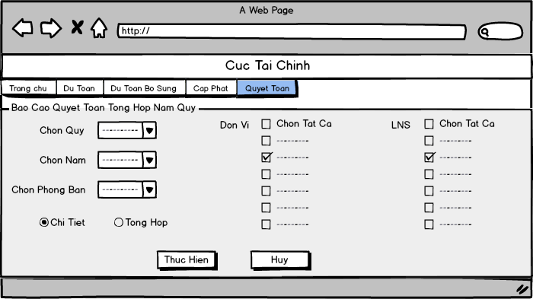

*“Quyết toán tổng hợp năm – quý” report screen*

### 3.4.16 UC059 - Export “*Quyết toán phòng ban*” Report

|  |  |  |  |
| --- | --- | --- | --- |
| **Use Case ID** | UC059 | **Version** |  |
| **Use Case Name** | Export “*Quyết toán phòng ban*” report | | |
| **Create By** | HungPX | **Date Created** | 20/10/2015 |
| **Primary Actor** | User | **Secondary Actor** | N/A |
| **Description** | Exporting the settlement report which includes information of settlement created by selected department | | |
| **Preconditions** | User has already logged in System  User has permission to export report  Have settlement’s data in database from vouchers | | |
| **Post conditions** | “*Quyết toán phòng ban*” report is exported | | |
| **Normal Flow** | 1. User selects [Quyết Toán] on the header of home page and click [Danh sách báo cáo] hyperlink 2. System redirect to [Danh sách báo cáo ngân sách quốc phòng] screen 3. User clicks on [Quyết toán phòng ban] hyperlink 4. System redirects to [Quyết toán phòng ban] screen 5. User selects all conditions to export report:  * Select the quarter in [Quý] dropdown list * Select Unit in [Đơn vị] dropdown list * Select department in [Phòng ban] dropdown list * Select budget type in [Loại ngân sách] list of check box  1. User clicks button [Thực hiện]. 2. System exports the report(s) in new page(s). Each unit report is exported in one page. | | |
| **Alternative Flows** | **In step 6. User clicks on [Hủy] button instead of [Thực hiện] button**   1. User clicks on [Hủy] button 2. System redirects to [Danh sách báo cáo ngân sách quốc phòng] screen | | |
| **Exceptions** | **N/A** | | |
| **Priority** | High | | |
| **Frequency of Use** | High | | |
| **Business Rules** | B2 | | |

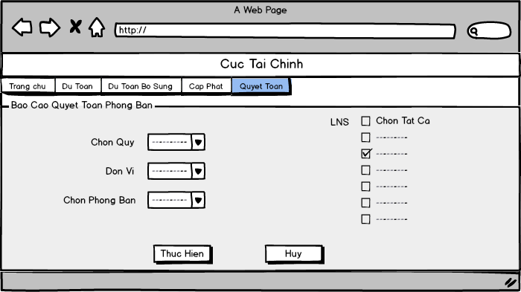

*“Quyết toán phòng ban” report*

# NON-FUNCTIONAL SPECIFICATION



## Reliability

* Mean time between failures: The mean time between each failure is about 6 month
* The maximum bugs per function are 2 bugs/a function when user uses software within 2 months. The average number of bugs in the software during system testing is about to be around 5 bugs/KLOC.
* The database must be backed up daily and can be recovered if necessary
* All parameter of system must be correct: allowed wrong number is two digits after comma and correct rounding

## Availability

* Percentage of availability time is about 24 per 7

## Performance

* In term of response time, waiting time of processing will be 0.5 to 1 seconds; waiting time to process normal functions will not exceed 2 seconds and process loading or combining data will not exceed 3 seconds.

## Maintainability

* **Coding standards and naming conventions**
* Output of the project must include coding standards and naming conventions documentations. Implementation code must be easy to maintain.
* All code must be clearly commented, including class, method documentations.
* If some components are reused, the documentations of those components must also be included.
* **Design**
* The design of the system must be loosely coupled that chances on some module will not affect others.
* **Mean time to repair**: Immediately when Administrator finds out problems. Average 0.5 day.

## Usability

* Usability Requirements support the following from the perspective of its primary users:
* **Efficiency of use:** User can complete each function is lesser than 10 actions.
* **Intuitiveness:** User can understand approximately 95% help/error messages
* **Interface:** Should be simple and clear.
* **Help facilities:** User will be trained a week about all the functions of system .Beside, user will be provided user guide to support

## Security

* In order to avoid unwanted access by strangers, the security implemented in various ways:
* **User authorize**: Functions will be show after users login dependencies user’s role and permission of each user. At early stage, User can use function cross each other in some actions.
* **Manage Data Layer**: Only Administrator can modify database system.
* **Stored Data**: All data about information must be saved in database, and be easy for data classification or backup...

## Hardware/Software Requirements

* **Hardware requirement:**
* **Server:** CPU 2.5 GHz, dual core or higher, RAM 4GB or higher
* **Client:** CPU 1.5 GHz or higher, RAM 1GB or higher
* **Software requirements:**
* **Server:** Window Server 2008 64bit, SQL server 2008-R2
* **Client:** Window XP, window 7 or later.

Client’s browser is (Firefox 17.0) with LAN Server connection.